Climate Outlook User Guide
The aim of the Met Office’s Climate Outlook product is to provide seasonal information, reviewing the last three months and looking forward 3-6 months, so that readers are informed of the seasonal variability affecting various countries. Multiple climate hazards such as drought, flooding and extreme heat are impacted by climate change, but also occur and can be predictable on seasonal (2-4 month) timescales.
The skill of long-range outlooks varies with the time of year and with location, due to fundamental differences in how dependent local weather conditions are on global-scale atmospheric and oceanic processes at different times and in different regions of the world. This is taken into account in the Climate Outlooks but the product should be used alongside shorter range forecasts and weather warnings as they become available.

From Weather to Climate
Weather is what you see when you look out of the window day to day. Over a long enough period, the pattern of that weather defines a climate. Climate describes the range of weather that you might get at a location over time, and the statistical properties of the weather, such as averages, extremes and how variable it is through the year or between years. By using historic information over a long period (ideally thirty years) an understanding of the normal climatological range and frequency is gained. A climate of a particular place is often described in seasonal periods (e.g. summer/ winter or rainy/ dry season) over the cycle of the year. The climate can also naturally vary between different years due to the process of Earth system cycles, especially those associated with large circulations of the atmosphere and oceans. Examples of this kind of variability over years include major influencing systems like the El Niño Southern Oscillation (ENSO) or the Indian Ocean Dipole (IOD). This natural variability imposes changes to the climate over a period of years or decades around some climate average.
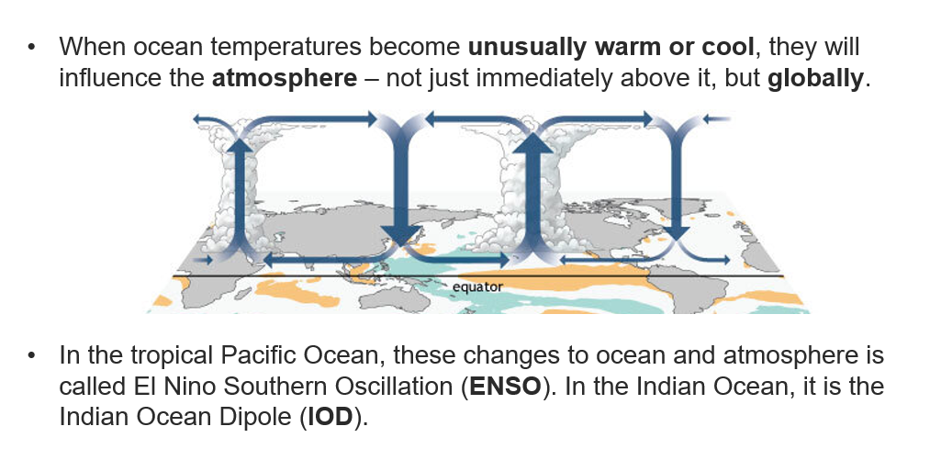

The differences in ocean temperature anomalies (departure from normal) from an El Niño year and a La Niña year can clearly be seen below:
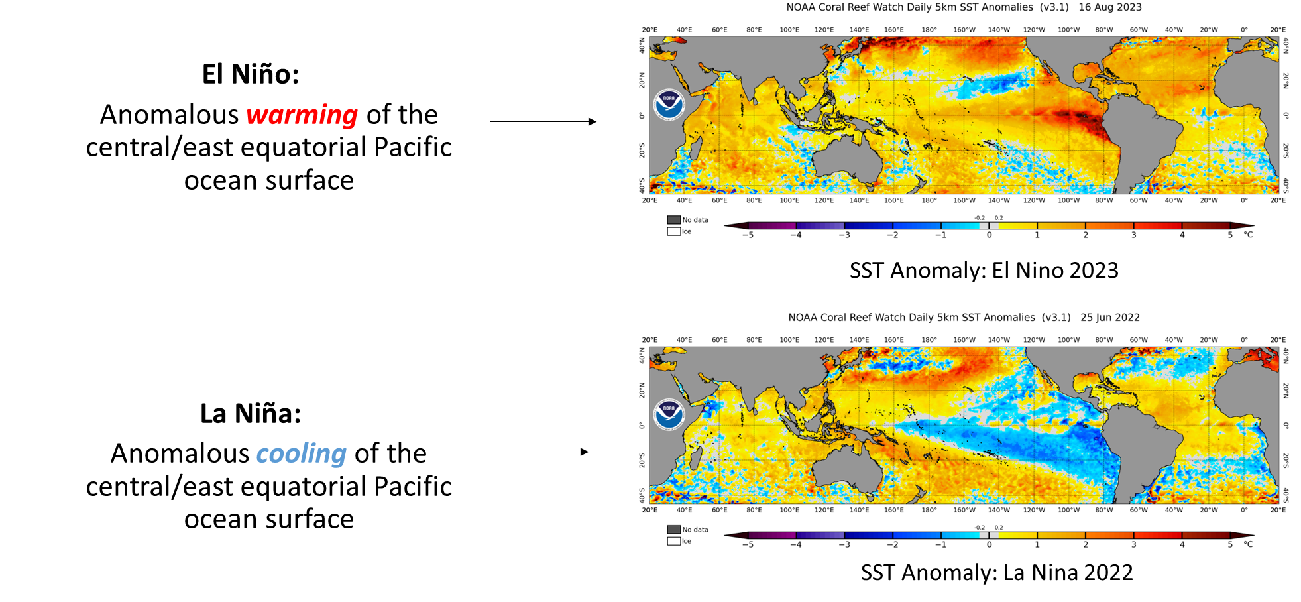
However, not every El Niño or La Niña year will be the same, we can only say there is an increased likelihood of wetter/drier conditions in certain locations for each. The typical areas which have rainfall impacted by an El Niño event or a La Niña event are shown below:
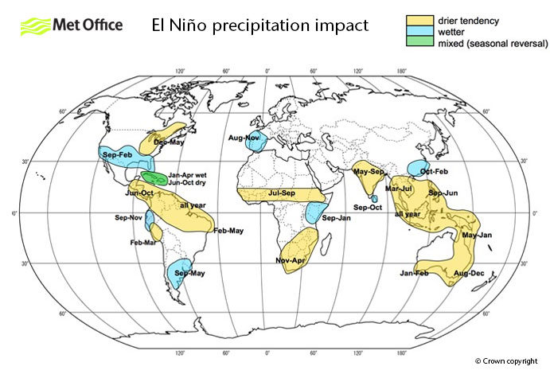
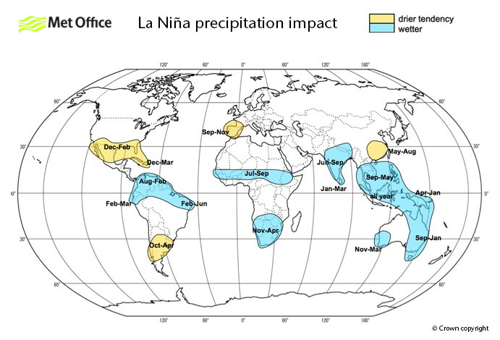

Seasonal Forecasting
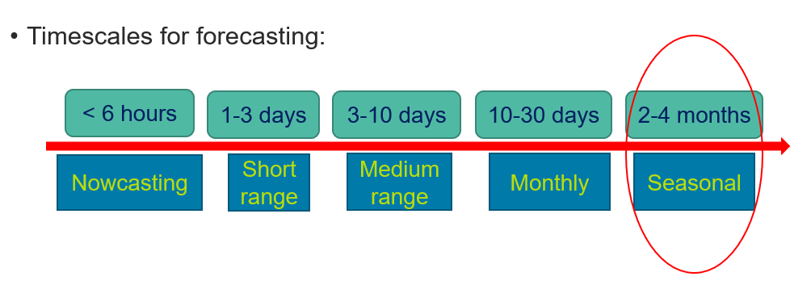
Weather forecasts provide information about weather conditions expected over the next few days, i.e. how much rainfall or what the temperature will be for a particular location. While it is generally not possible to predict these precise day-to-day changes in detail beyond about a week ahead, it is possible indicate whether conditions over a season are likely to be wetter, drier, warmer or cooler compared to a long-term average (e.g. warmer than normal). The graphic below shows you can formulate statements of above and below normal for a hypothetical month.

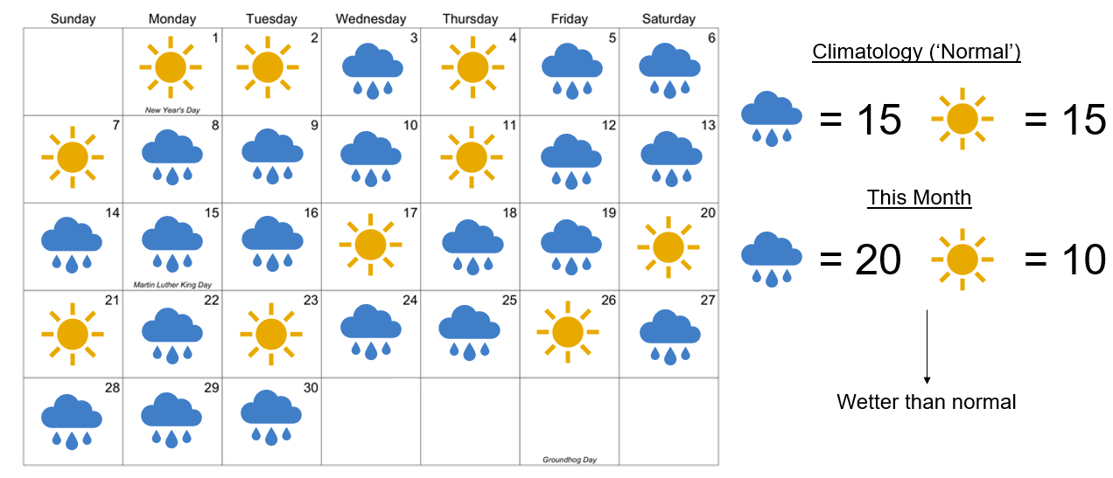
Many global atmospheric models are run forward in time (up to 6 months) many times with slight variations in the starting conditions to represent uncertainties in the forecast process and observations. This ensemble (or a set of forecasts) can then provide a likelihood of what could occur, termed a probabilistic forecast. The larger the spread in the ensemble (see image below), the larger the uncertainty in the resulting outlook.
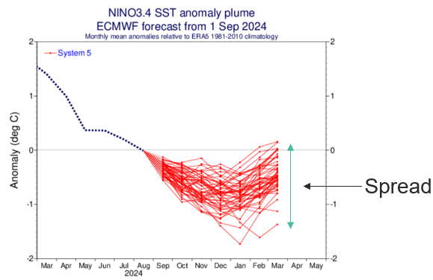
The Climate Outlook product utilises multiple seasonal model ensembles, from different global weather centres, combined into a ‘multi-model’ output. The Supplemental Information section of the Climate Outlook lists the models used and provides a link as to how these are technically combined. In general, seasonal forecasts reduce in confidence as the forecast time looks further ahead, therefore, the 4-6 month outlook should be viewed with less confidence than the 1-3 month forecast. The 1-month outlook uses a combination of both weather forecasts and sub-seasonal models; it will usually be the most accurate of the three outlook periods.
Different models will have different skill (a model’s ability to reproduce observed conditions using hindcasts – historical forecasts compared to observations), which can be assessed over many years to learn about model performance in different areas. Skill varies depending on the model, season, variable, lead-time and location. This is why a team of experts produce the Climate Outlooks, to bring together all the information in a usable format.

Use of relative terms
The Climate Outlook product uses relative terms to describe historic climate variation and forecast climate trends which differ from the normal climatological range. As described above, seasonal models provide likely conditions averaged over several months and across large spatial areas. Therefore, the information is not specific to a point in time and location, rather it gives broad indication of average variation. The second reason for using relative terms is due to standard variations in temperature and precipitation experienced during a day, or over a month, across region or a country. In a single location, there are diurnal (daily) variations of temperature throughout a 24hr day and this variation may change as the month progresses. Additionally, across a country there will be different climatic regions (mountainous, desert, coastal….) each of which will have a different standard daily range of temperature or precipitation amounts. A national monthly average will combine all these different regions and daily variations into one, making relative terms more useful for application in a particular area.

Sections in the Climate Outlook
Overview
This section provides an overview of the current status and outlook at the regional and global level, with narrative information on significant conditions and trends. Information on key drivers of climate (such as Sea-Surface Temperatures, El Nino and the Indian Ocean Dipole) will be included in this section.
Current Status
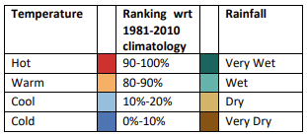
This section provides maps showing recent temperatures and precipitation, and information at a country level for the recent observed conditions. As the Current Status information is based on analysis of observed conditions, we can be more precise with the variation information. The graphical plots display the extreme variations, and the percentiles indicate a ranking of temperature or rainfall, with the 0% being coolest or driest and the 100% being the hottest or wettest compared against the 1981-2010 climatology. The monthly country tables assess variations over the whole country, and large sub-national anomalies will generally be highlighted over a simple country average to better help the reader understand where there are trends.
Outlooks
This section provides information at a country level for conditions in the coming month, 1-3 months and 4-6 months. In the Climate Outlook, the relative terms used have defined meanings which enable the best interpretation of the model information available. For each month, the climatological range over 30 years is divided into three equally likely sub-ranges (below normal, near-normal and above-normal), such that over many years there will be equal probability (33%) of the monthly average falling into one of these three sub-ranges. These sub-ranges are known as terciles. Seasonal modelling predicts whether there is a higher or lower likelihood of being in the below normal, near normal or above normal tercile.

To facilitate interpretation of the information, descriptive phrases for temperature and rainfall variation are used instead of below normal and above normal:
- Temperature is described as warmer (above-normal) or cooler (below-normal);
- Rainfall is described as wetter (above-normal) or drier (below-normal). Rainfall information includes all types of precipitation, e.g. rain, hail, snow, drizzle….
The phrase ‘likely’ is used when the probability is above 40% (climatological average would be 33%) and below 70%. When the probability is over 70% then the phrase ‘much more likely’ is used. This indicates a very strong signal for the relevant tercile and if referring to an upper or lower tercile then it is also reasonable to infer that there is also increased likelihood for more extreme conditions. Where none of the terciles have a probability above 40%, then the phrase ‘climatological odds’ will be used. This means the outcome could fall anywhere within the possible climatological range and near-normal conditions should not be assumed (it means there is no strong signal for any particular tercile).

For further information please contact: internationaldevelopment@metoffice.gov.uk

