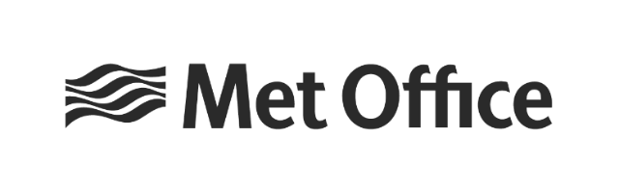
www.metoffice.gov.uk © Crown Copyright 2023, Met Office

Equality, Diversity & Inclusion Progress Report

Document history
Version | Purpose | Date
1 | Draft
2 | Revised draft with comments
3 | Final draft for inclusion with Met Office Board report | 09/05/2023
4 | Amendments made following feedback from Met Office Exec Board meeting. | 23/05/2023
5 | Foreword included | 26/05/2023
6 | Amendments made to figures in Education Outreach section | 31/05/2023

Prepared by
Neil Murdoch, Equality, Diversity & Inclusion Lead, 9 May 2023
Susan Ward-Rice, Equality, Diversity & Inclusion Advisor, 9 May 2023

Reviewed by
ED&I Committee, April /May 2023

Authorised for issue by

Contents
Document history 2
Prepared by 2
Reviewed by 2
Authorised for issue by 2
1. Foreword 5
2. Introduction 6
3. Terms Used in Report 7
4. Our commitment to Equality, Diversity, and Inclusion (ED&I) 8
4.1. Governance 9
5. Key achievements for 2022-23 10
Objective 1: Engaging with and understanding the diversity of our people and those we serve 10
Objective 2: Advancing equality of opportunity 10
Objective 3: Increasing representation of under-represented groups at all levels 10
Objective 4: Zero tolerance to bullying, harassment and discrimination 11
6. Staff Networks 11
6.1. Some network highlights. 12
6.1.1. Religion & Philosophical Belief Network 12
6.1.2. Internationals in the UK 12
6.1.3. Accessibility & Disability Network 13
6.1.4. Menopause Network 14
6.1.5. Shift Workers Network 14
7. Wellbeing 14
7.1 Mental Health First Aiders 15
8. Dignity & Respect 16
9. Our Diversity and Inclusion highlights 16
9.1. Making our Awards for Excellence ceremony more inclusive 16
9.2. Embracing Hybrid Working 17
9.3. MetNet - Creating an inclusive intranet 18
9.4. Empathy Lab 18
9.5. Say My Name – Audio name-badges 18
9.6. Making workplace adjustments more inclusive 19
9.7. Equality Impact Assessments (EqIAs) 19
9.8. Education Outreach 20
9.8.1. 2023/24 Education Outreach Developments 21
9.9. Partnership Working 22
10. Inclusive Recruitment 24
10.1. Applicant data 24
11. Gender Pay Gap Reporting 26
11.1. Comparison with the Civil Service 26
11.2. Ethnicity Pay Gap reporting 27
12. Workforce Diversity 28
12.1. Diversity data headlines 28
12.2. Further work to do on our data 29
13. Early Careers 29
14. Public customer data 31
15. Looking ahead – ED&I Action Plan 2023-2024 32
Objective 1 – Engaging with and understanding the diversity of our people and those we serve 32
Objective 2 - Advancing equality of opportunity 32
Objective 3 - Increasing representation of under-represented groups at all levels 32
Objective 4 - Zero tolerance to bullying, harassment and discrimination 33
16. Appendix: Workforce Diversity 34

Foreword
Welcome to the Met Office’s second annual Equality, Diversity, and Inclusion (ED&I) progress report.

Just looking at the content of this report, one can see the work touching across all aspects of the ED&I. I am grateful to Penny Endersby, Tammy Lillie and Jon Petch’s leadership in pushing the agenda and accelerating progress so that every person is treated with fairness, dignity and respect throughout their Met Office journey. At the same time, they continue to remind us that it has to be a collective effort from the board to the teams on ground.

In order to deliver work that benefits the wider society and meets the Met Office objectives, we need to value each other and therefore need to ensure there is equal respect as well as equity of access and opportunity for everyone. To enable this to happen we must be diverse, inclusive and equitable in our approach and make ED&I pervasive in everything we do. It’s heartening to see the cross-organisation and local team efforts in driving this culture of inclusion.

The Met Office is a data driven and customer focused organisation. The insights gained from the equality, diversity and inclusion data, networks and customers are now being applied to help improve how we operate and engage with others. We aim to be transparent in our diversity and inclusion approach ensuring our progress and improvement can be clearly seen by our staff, public and customers. This open and honest approach, is what I believe, will help drive the positive change and equip every person at the Met Office to not only deliver better outcomes for the Met Office and wider society but also make their own journey at work a pleasant and rewarding experience.

Professor Anusha Shah, CEng, FICE, Hon DEng, Hon. Prof
Non-Executive Director
Introduction
The Met Office is the national meteorological service for the UK. We provide critical weather services and world-leading climate science. We are here to help you make better decisions to stay safe and thrive, this means giving you the best weather and climate information when it matters to you most.
Founded in 1854 by Vice-Admiral Fitzroy with the purpose to learn more about marine climatology as this would improve the safety of life and property at sea. When the Royal Charter sank in October 1859, Fitzroy argued for a supply of coastal observations. These observations were used to create a new storm warning service, now known as the iconic shipping forecast and in 1861, the first daily public weather forecast was published.
Since our foundation, we have pioneered the science of meteorology and we continue to push boundaries of science and technology, so that we can meet the demands of today and the future.
We are a key part of the weather and climate community with our team of weather and climate experts playing a critical role in interpreting our data, turning this into insight and advice which saves lives and helps people make decisions day-to-day.
We have earned a reputation for continually pushing the boundaries of scientific, technological, and operational expertise.
We are responsible for weather and climate information and severe weather warnings helping the UK government, businesses, emergency responders and public make informed decisions.
We also work in partnership with a wide variety of organisations in the UK and around the world, including:
- A network of academic and research relationships such as the Met Office Academic Partnerships.
- National governments and non-governmental organisations to improve global weather and climate provision such as
- Emergency services such as RNLI, Shelterbox and Air Ambulance providing accurate forecasting.
The Met Office is an executive agency of the government, and all staff are Civil Servants. In February 2023, the Prime Minister changed the structure of government departments and as part of these changes the Met Office’s ownership moved to a new department called the Department for Science, Innovation and Technology. We continue to work closely with other departments including the new Department for Energy Security and Net Zero.
We have 2294 (as of 1 March 2023) employees working from sites across the UK and abroad. Our head office is located in Exeter, Devon, in the southwest of England.

Terms Used in Report
Civil Service is politically impartial and independent of UK government and helps the government of the day develop and implement its policies as effectively as possible.
Diversity is the differences in colour, ethnicity, abilities, age, gender, beliefs, interests, socioeconomic (class), marital or partnership status, sexual orientation, geographic, academic/professional backgrounds, opinions, backgrounds, thinking, experiences, and many other characteristics (CIPD, 2023).
Equality is about ensuring equality of access, treatment, outcomes and impact in both employment and service delivery. It is rooted in ideas of justice and fairness and enshrined in the Equality Act 2010 which highlights that every individual must have an equal opportunity to make the most of their lives and talents. It is also the belief that no one should have poorer life chances because of their background, personal identity, or experience (CIPD, 2023).
Inclusion is the practice of including people in a way that is fair for all, values everyone’s differences, and empowers and enables each person to be themselves and achieve their full potential and thrive at work (CIPD, 2023).
Protected Characteristics. In the UK it is against the law to discriminate against someone because of age, disability, gender reassignment, marriage and civil partnership, pregnancy and maternity, race, religion or belief, sex and sexual orientation. These are called protected characteristics and more detail can be found in the Equality Act 2010.
Methodology – we are working to ensure all our protected characteristic fields meet the Office for National Statistics UK best practice.
All data on gender is collected globally. Our gender pay gap uses the Government Equalities Office methodology which is based on sex at birth or subsequent gender recognition certificate. Gender identity elsewhere is based on self-declaration. Numbers for gender may not total 100% due to inclusion of people who identify as transgender, non-binary, or who choose not to disclose.
Data reporting - Numbers may not total 100% due to inclusion of people who choose not to disclose. We have a duty in the UK not to disclose sensitive information in a format that may identify staff.

Our commitment to Equality, Diversity, and Inclusion (ED&I)
We are still on our ED&I journey and have made significant progress in the last couple of years, but we know some of the work we are doing will take time to have an impact. We are passionate about equality, diversity and inclusion and want to create a sense of belonging for all, celebrating difference, and treating each other with dignity and respect.
As a public body, we also must comply with the Equality Act 2010 and specifically the Public Sector Equality Duty (PSED), this requires us to consider the impact of our activities and services on people who identify with one or more of the nine protected characteristics and also take proactive steps to:
- Eliminate unlawful discrimination, harassment and victimisation and any other conduct prohibited by the Act;
- Advance equality of opportunity between people who share protected characteristics and people who do not; and
- Promote good relations between those who share protected characteristics and those who do not.
In 2020, we launched our first Equality, Diversity & Inclusion Strategy. This set out our approach to ED&I and included our equality objectives. The first objective was amended in late 2021 to reflect that we deliver services to a wide range of customers:
- Objective 1: Engaging with and understanding the diversity of our people and those we serve.
- Objective 2: Advancing equality of opportunity.
- Objective 3: Increasing representation of under-represented groups at all levels.
- Objective 4: Zero tolerance to bullying, harassment and discrimination.
We plan to review our strategy and objectives over the coming year in line with legislation.
Our equality objectives also align closely with the current Civil Service objectives which are a Civil Service that:
- understands and draws from the communities it serves – drawing from a range of backgrounds, experiences, and locations.
- is visible to everyone – engaging the communities we serve and showcasing what the Civil Service offers.
- is flexible – supporting innovation, performance, and engagement.
- welcomes talent from wherever it comes – attracting the best talent from all backgrounds.
Our annual ED&I action plan links to both our objectives and strategy and describes what we will focus on over the next year. This plan is regularly reviewed and updated in light of both internal and external changes such as ensuring we are supporting the delivery of key government strategies including:
- The Civil Service Diversity and Inclusion Strategy - 2022-2025 - Promoting Fairness and Performance (February 2022).
- Inclusive Britain - Government Response to the Commission on Race and Ethnic Disparities (March 2022).
- National Disability Strategy (July 2021).
This report details our progress over the last year, highlighting some of our achievements, and how we want to move from a position of basic compliance to a position where equality, diversity and inclusion is part of our visible culture and DNA in our approach. It also outlines some of our priorities for 2023-24.

Governance
Our ED&I Committee monitors progress against our ED&I strategy by regularly reviewing the ED&I action plan and reporting updates to the People Committee and the Met Office Board twice a year. The committee has representation from all directorates within the Met Office, and these representatives help to drive change in their respective directorates.
The Diversity Council meets monthly and each of our staff networks and sponsored groups is represented. The council is an opportunity to share good practice but also to discuss issues of concern and escalate to the ED&I committee when necessary.
The ED&I action plan is a mixture of cross organisation and directorate specific actions which are relevant to certain professions or types of work conducted in the Met Office. Our action plan is data driven and evidence led and plays a crucial role embedding ED&I into all our directorates.

Key achievements for 2022-23

Objective 1: Engaging with and understanding the diversity of our people and those we serve
- Increased staff diversity declarations from 92% in April 2022 to 94% in March 2023, whilst also reducing the number of employees who leave one or more fields blank by 10%.
- Organised staff network events using our coordinated ED&I calendar of events.
- Identified certain groups and demographics of the UK public that were less likely to have access to weather forecasts.
- Developed a dashboard to analyse our people survey by protected characteristic to support directorate action plans. This is also allowing us to see the impact of education and staff socio-economic backgrounds.
- Developed a dashboard to allow us to analyse the impact of our outreach activity and its links to our early careers’ recruitment.

Objective 2: Advancing equality of opportunity
- Improved the perception of Inclusion and Fair Treatment in our Asian or Asian British and Mixed or Multiple Ethnic staff groups in the 2022 people survey (our Black or Black British group gave us the maximum score).
- Shortlisted for a wellbeing award by National Highways.
- Joined Business Disability Forum, enabling us to access expert advice and support, 250 employees have accessed Business Disability Forum Knowledge Hub resources.
- Reviewed our Mindful Employer Charter and commenced assessment by Great Place to Work.
- Improved our Science Progressions processes and re-energised our talent management approaches.

Objective 3: Increasing representation of under-represented groups at all levels
- Identified work opportunities with Civil Service for candidates with a disability or long-term health condition through the Summer Diversity Internships and Autism Exchange.
- Analysed our staff and recruitment data against the UK working age population and identifying subsequent actions based on the data running up to 2025.
- Worked with Business Disability Forum to improve policies.
- Raised staff awareness to digital accessibility.
- Continued to use our people stories to foster compassion, connection and understanding amongst our colleagues.

Objective 4: Zero tolerance to bullying, harassment and discrimination
- Collaborated with our People Development team to identify the training needs of our Dignity and Respect at Work Advisors (DRaW) and staff network leads.
- Used Anti-Bullying Week to highlight the work of DRaW advisors and also promoted zero-tolerance to bullying, harassment and discrimination.
- Signed the Exeter Safety of Women at Night (SWaN) Charter.
- Worked with our Internationals Network to undertake a hate crime survey.
- Launched Say My Name project to promote respectful interactions around names.
- Launched a Building Respect Campaign to challenge inappropriate behaviours.

Staff Networks
We want the Met Office to be a great place to work, our staff networks are critical to us achieving this. With the addition of the Religion and Philosophical Belief Network in the autumn of 2022 and the amalgamation of the Dementia Carers and Carers Support networks we now have 12 networks.
Our networks help:
- people feel like they belong, providing a supportive and safe place for employees to share their experiences.
- improve our working environment by providing advice and guidance.
- in providing feedback on policy formation and contributing to equality impact assessments.
- in undertaking accessibility testing.
They work closely together providing an important source of mutual support and solidarity on common issues.
Over 400 people engage in our networks and sponsored groups. Each network is sponsored by a member of the Executive Leadership Team. Recently colleagues from People Development have worked with network leads to identify areas of development and support.
Several networks in the last year have experienced changes in leadership which has led to some networks having co-leads, so two colleagues’ job-sharing the role. This is leading to better sustainability of networks and something that we are encouraging. All leads receive an allocation of time to undertake their role and we are encouraging networks to use our ally community to support initiatives and events.
All staff networks and sponsored groups are represented at the Diversity Council, providing updates on network activity but also sharing concerns and issues which are escalated to the ED&I Committee if needed.

Some network highlights.

Religion & Philosophical Belief Network
This is our newest network, bringing together a diverse set of beliefs including Paganism, Christianity, Islam, Buddhism, and Humanism but not political belief. This network has had a busy few months, working with our property services to create a faith and reflection space, where employees can take a moment for prayer and religious observance or quiet contemplation. The network for the coming year is planning activities for Inter-Faith Week in November.
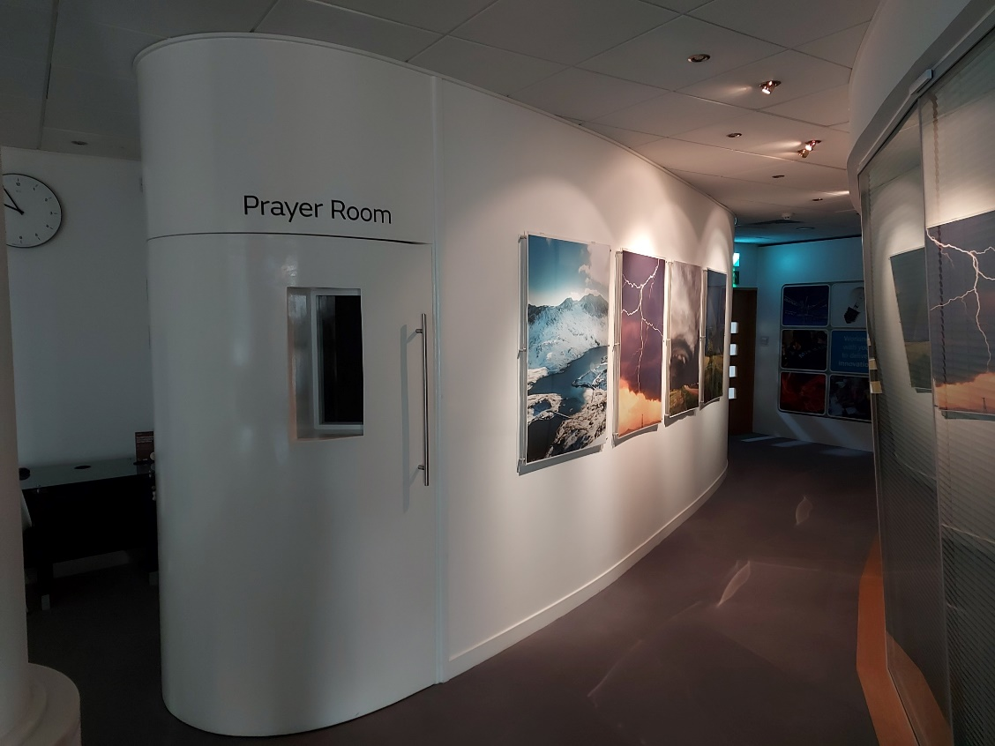

Internationals in the UK
Our Internationals in the UK network was one of our first staff networks, having started in 2011. This network supports and celebrates the international character of the Met Office. The network supports employees and visiting scientists from outside the UK by:
- Providing practical advice of living in the UK.
- Improving language skills via a weekly lunchtime English conversation group.
- Hosting social events.
To celebrate and recognise International Cultural Day, a visiting scientist from the Korea Meteorological Administration (KMA) facilitated a session about the cultural differences between Korea and the UK. Offering his insight on a range of subjects including food, education, housing, the workplace, and the many keys British houses have!
The network has also acted against hate crime, this follows on from an incident of racist abuse a visiting scientist experienced in a public area in Exeter. Working with the ED&I team, the network developed a survey to understand experiences of hate crime. Initially shared with members of the network and then more widely during Hate Crime Awareness Week in November 2022. Over two-thirds of those who responded had been a victim of hate crime in a public space.
As a result, we are updating our ED&I Hub to include information on how to report hate crimes and the support available for victims. The findings have also been shared with Exeter Community Safety Partnership, who are keen to encourage other organisations within the city to undertake surveys.



Accessibility & Disability Network
As well as supporting colleagues, our Accessibility & Disability Network have been pivotal in assessing the accessibility of our new intranet – MetNet. In the past year, they have also:
- Provided feedback on the layout, colours, and sound levels of our quiet floorplate (a working space similar to a library).
- Provided advice about how to improve the accessibility of our Awards for Excellence event.
- Undertaken a review of training modules and feeding back on inaccessible learning materials.
- Assessed the usability of our new Health & Safety reporting app.

Menopause Network
In 2022, the Met Office signed the Menopause Workplace Pledge, demonstrating our intention to support employees who are experiencing the menopause, the signing of this pledge was led by our Menopause Network. The network collaborated with our People Team to develop guidance and a pocket guide for line managers to raise awareness of menopause transition and how to have supportive conversations with colleagues.

Shift Workers Network
Our Shift Workers network supports a range of employees that span weather forecasting, flood forecasting, and observations. In 2022, the network developed a series of seminars with the aim of helping shift workers thrive by recognising how shift work can impact on health, safety, and wellbeing. Monthly seminars were held covering a range of topics including sleep and sleep science, wellbeing, communication, time management and career coaching.
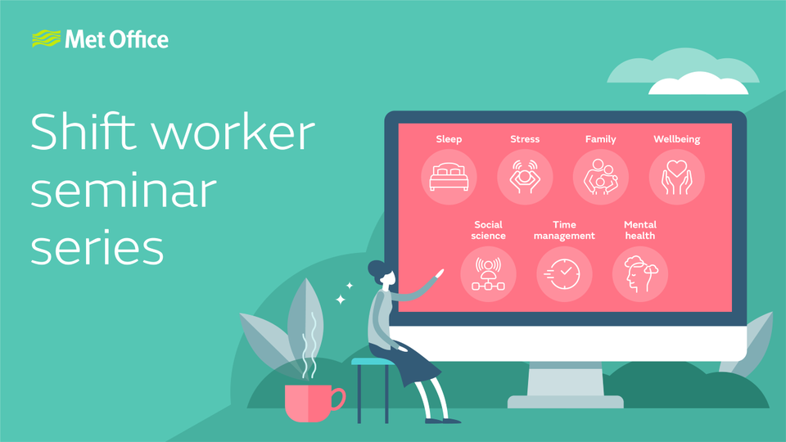

Wellbeing
We have a strong commitment to wellbeing, recognising that a good working environment can positively impact on the health and wellbeing of our employees. We want to create a culture where we talk openly about our challenges and where we signpost to appropriate support.
Some of our wellbeing highlights over the last year include:
- Finalists in the Highways Awards in the Mental Health & Wellbeing Award category.
- Improved our Wellbeing Hub to be a central location for resources, self-help tools and signposting.
- Trained 24 colleagues to be Wellbeing Champions.
- Reviewed and updated our Wellbeing Strategy.
- Established Wellbeing Advocates in each directorate senior leadership team to sponsor and support wellbeing champions.
- Renewed our Mindful Employer Charter.
- Designed and launched a Wellbeing Dashboard to monitor wellbeing across the organisation.
- Created a ‘Cost of Living’ hub to signpost employees to support available including financial advice.
- Expanded our wellbeing learning opportunities to include Mental Wellbeing at Work.
- Regular communications under our ‘Five ways to wellbeing campaign’ focusing on themes such as Christmas time, loneliness, anxiety, suicide awareness and World Mental Health Day.
- 46 employees have participated in our wellbeing workshop and 50 managers have participated in Connect 5 training (a mental health and wellbeing programme designed to increase confidence and skills).
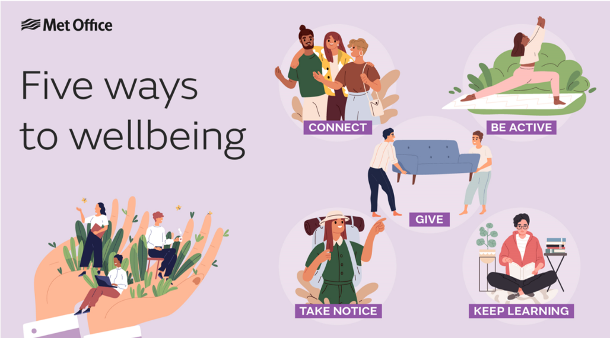

Mental Health First Aiders
The Met Office’s Mental Health First Aider team is an information and signposting support service for employees and managers. Our team of 30 volunteers are trained to recognise the signs and symptoms of common mental health issues and provide help on a first aid basis, signposting to appropriate support. In the last year, our Mental Health First Aid team has undertaken refresher training to improve their knowledge and practice.

Dignity & Respect
Bullying and harassment undermine dignity and respect and we have a zero-tolerance approach to such incidents. We want a workplace where staff, contractors and visitors have the confidence to report harassment or bullying without fear of victimisation.
We have a network of Dignity and Respect at Work Advisors (DRaW), members of staff who volunteer their time to provide a confidential and informal service to staff on issues relating to unacceptable behaviour including bullying, harassment, and discrimination. Volunteers provide a listening ear without judgement and signpost to sources of support and next steps.
In the last year, we have been working with the DRaW volunteers to identify training needs and improve monitoring, so we can better understand the number of people contacting DRaW and the reasons why.
We used Anti-Bullying Week to also raise awareness of DRaW and other sources of support such as our Employee Assistance Programme through a toilet door poster campaign across our office locations.
As members of Exeter Community Safety Partnership, we signed the Exeter Safety of Women at Night Charter. The charter unites organisations in developing a whole-city approach to keeping women and girls safe at night in Exeter. The charter includes a number of pledges that we are keen to support, such as:
- Supporting our staff by creating clear routes for reporting unacceptable behaviour while at work.
- Designing for safety - auditing our spaces and adapting them to promote a safer environment.
- Changing the conversation with regular conversations about women’s safety.
We are working with our networks to develop actions for the year ahead.
Our Programmes directorate have developed a Building Respect pilot, which uses ambassadors across the directorate to facilitate conversations within teams about acceptable and unacceptable behaviours. A toolbox of resources is currently in development to support ambassadors in this role. The aim of the pilot is to encourage a culture where everyone receives respect, can work effectively, and voice their views and perspectives.

Our Diversity and Inclusion highlights

Making our Awards for Excellence ceremony more inclusive
The Met Office’s Awards for Excellence is an opportunity to celebrate and recognise both individual and team successes, the awards showcase all that’s good about the Met Office and are centred around our values.
Following two years of online awards events due to COVID-19 restrictions, our awards in December 2022 offered the opportunity for a return to ‘real life’ celebrations. However, we wanted to build on the success and inclusivity of our virtual events and continue to consider the needs of colleagues who are not located in our Exeter headquarters.
Our event comprised of an in-person event in Exeter that was live streamed and accessible to all staff and locations, as well as the recording being available after the event. We also collaborated with members of our Accessibility & Disability Staff Network to make the event more inclusive by:
- Having reserved seating near the stage.
- Creating an accessible refreshments seating area.
- Ensuring any films created did not include loud music or flashing.
- Creating a quiet zone for people to watch the awards in the building but away from the actual ceremony.
- Ensuring the stage was fully accessible with steps and a ramp.
“Thank you, Internal Comms, for going the extra mile to make things accessible and inclusive this year. I was very glad to have a quiet room to watch the awards”.
Met Office employee, 2022

Embracing Hybrid Working
As an organisation, we have been looking at the way we work since May 2020. Over the past year, we have been focussing on providing an effective and practical hybrid working environment with a culture of wellbeing, flexibility, and diversity at its heart. In the last year, we have:
- Redesigned one of our floorplates into a quiet workspace, for staff who need a quiet space to concentrate on work.
- Introduced dedicated spaces to take Teams calls or have one-to-one conversations.
- Introduced Microsoft Surface Hub S2 devices (interactive whiteboards for remote working) in various Exeter meeting rooms.
- Created technology etiquette so continuing to raise awareness about ensuring meetings are inclusive and accessible for all.
- Produced regular news stories sharing people’s experience of using new technology or spaces.
- Refreshed Team Charters, so they continue to provide a common framework and narrative for teams to be able to share and understand each other.
As we embrace hybrid working, our emerging guidance will allow employees and managers to make appropriate decisions on how they work, so maximising performance and productivity whilst maintaining a good work/life balance.

MetNet - Creating an inclusive intranet
MetNet is the Met Office’s intranet, serving colleagues across the organisation with news, updates, and key information on a daily basis; acting as a one stop shop for all colleagues.
Our old MetNet was hard to navigate, information was difficult to find, and it didn’t meet accessibility compliance guidelines. The goal of the new MetNet project was to create not just a new intranet but a digital workplace which provided better opportunities to connect and collaborate.
Focus groups helped to identify user requirements, what worked and what didn’t, and our Accessibility & Disability Staff Network played a crucial role in user testing and feeding back about accessibility.
Our new MetNet launched in July 2022, it is integrated with Microsoft 365, making it much easier to find information and has a much-improved search functionality.

Empathy Lab
In January 2022, we hosted our first Empathy Lab, a three-day event in partnership with All Able. The Empathy Lab was an opportunity to facilitate discussion and raise awareness of digital accessibility through interacting with a range of assistive technologies. Over 270 employees participated in the event, by either visiting the market stand in our Exeter building or attending virtual or bespoke team sessions.
As part of the event, we developed ’10 steps to digital accessibility’, practical guidance employees could take away and immediately implement.
Following the event, a steering group has formed to grow knowledge and skills of digital accessibility across the Met Office.

Say My Name – Audio name-badges
Our names are entwined with our personal identities, often chosen with care and laden with meaning, yet for some colleagues, their name is routinely mispronounced and for others their first names and surnames are mixed up. Our ED&I Team, and Black and Asian Minority Ethnic Staff Network launched the Say My Name project in October last year. Working with the Social Inclusion Team at Warwick University, volunteers were asked to create an audio name-badge within their email signature and evaluate how useful it was as a tool. Over 50 people participated in the pilot, with the majority of participants agreeing to keep using the badge after the pilot. Work is now taking place to include audio name-badges in our branding guidelines for email signatures.

Making workplace adjustments more inclusive
Changes to Access to Work funding, gave us an opportunity to review our workplace adjustments guidance and process. As part of this review, we conducted a survey to understand employee’s experiences and the results showed that we needed to improve our process and guidance. We know that even making small adjustments can have a positive impact on the wellbeing, experience and performance of our colleagues and help staff feel more valued and supported.
Over the last year we have:
- Brought together a cross directorate working group to improve our workplace adjustments offer.
- Centralised the costs for all workplace adjustments, using a dedicated cost centre for all requests.
- Developed a software catalogue which includes assistive software applications that are approved for use on Met Office devices.
- Started to make information easier to find on the People Centre.
- Engaged with our Staff Networks and kept them informed with our ideas.
In early summer, we will be launching our new guidance along with introducing a workplace adjustments passport; a passport that can be used by any member of staff who feels they may need additional support at work. This is in recognition that we all may require a workplace adjustment at some point in our working life, and that adjustment may be on a temporary or long-term basis. For example, staff who:
- Have caring responsibilities.
- Are observing religious events.
Are transitioning.
- Require structured breaks for specific medical reasons.
- Are experiencing menopausal symptoms.
- Require specialist software such as speech recognition tools or ergonomic adjustments to workstations.

Equality Impact Assessments (EqIAs)
As a public body we are required to have due regard to the need to eliminate discrimination, advance equality of opportunity and foster good relations when making decisions and developing policies. To do this, we need to understand the potential impacts our proposed activities have on different groups of people, so we undertake equality impact assessments. Examples of where we might do an EqIA include:
- Implementation of a new strategy or policy.
- Redesign of a floorplate in our offices.
- Restructure of teams or areas of business.
- Introduction of change initiatives as part of our change management process.
- Events such as our awards ceremony.
In May 2022, we launched our EqIA learning workshop, the workshop offers colleagues the opportunity to increase their awareness and understanding of EqIAs, so enabling them to be more confident about completing an assessment. Over 25 people have participated, and additional ad-hoc team sessions have also taken place. Over 40 EqIAs have been undertaken.
We want to develop this work further over the coming year and look at whether we can create a digital EqIA template, this could help increase completion rates but also help us to monitor actions identified in EqIAs better.

Education Outreach
Our Education Outreach programme contributes to achievement of the Met Office purpose via two key objectives aimed at 3-18-year-olds:
Objective 1
To help young people stay safe and thrive during severe weather and in a changing climate by helping them to learn about weather and climate and act with confidence. This includes knowing where and how to access authoritative, reliable information.

Objective 2
To help young people discover the wide variety of careers at the Met Office and related sectors. Communicating the current and future skills we need.
Running parallel to these is a support objective to increase the number and diversity of young people reached by the Education Outreach programme. This strengthens delivery in a number of ways.

- It enables a greater and more diverse range of the population to make better sense of scientific information and act on it.

- It helps to increase the number and diversity of students within the pipeline of future talent (feeding into Early Careers provision), to better enable current and future skills gaps at the Met Office and across the Science, Technology, Engineering & Maths (STEM) sector to be filled and broader Met Office diversity targets to be met.

- It contributes to increased equity in education.
The Education Outreach Programme is being developed and delivered with both equal access and equity of opportunity in mind. As such, delivery to those whose demographic characteristics are underrepresented among the Met Office and wider UK STEM workforce is prioritised. However, this does not exclude young people in overrepresented groups. This is in line with the Public Sector Equality Duty (PSED) requirement to ‘advance equality of opportunity between persons who share a relevant protected characteristic and persons who do not share it’.
Data from 2022/23 provide an indication of Education Outreach programme reach, allowing us to assess current scale and diversity of outreach according to the number and type of groups reached, cross referenced against government ED&I data available for schools. A more comprehensive and robust baseline is being developed across the 2023/24 academic year which will allow additional detail to be considered in future years.
One hundred and eighty-three direct requests for Met Office Education Outreach were made during the 2022/23 financial year, from across the UK.
The table below divides those requests by type of group against the number provided. We were able to satisfy 24% of requests for Education Outreach in total, with the greatest proportion of requests fulfilled being for Further Education (83%).

Type of education establishment | Number of establishments
State primary | 46
State secondary | 47
SEND | 8
Independent | 19
FE | 1
PRU | 1
Home Education Groups | 3
Community Groups | 14
N.B. SEND: Special Educational Needs and Disabilities; FE: Further Education; PRU: Pupil Referral Unit

2023-24 Education Outreach Developments
Underrepresented groups are identified from the latest Met Office Diversity Data and UK STEM workforce data, when compared against UK population demographics. Considering each of the Equality Act 2010 protected characteristics, we can conclude that priority characteristics for 2023/24 are:
- Disability
- Ethnic minority groups
- Sex
Additionally, the Education Outreach programme is prioritising young people according to the following additional diversity indicators, which have historically been linked to disadvantage in education and career opportunities.
- Carers and those who are care-experienced.
- Socioeconomic background.
- First in family to attend/potentially attend university.
Of those groups underrepresented within the UK STEM workforce, studies have shown that socioeconomic status is the greatest predictor of whether a young person follows a pathway into the STEM sector.
To reach an increased number and diversity of young people across the UK and enable us to fulfil a greater number of direct requests we will:
- Provide downloadable support materials and virtual CPD for teachers and community group leaders, expanding our successful Met Office for Schools provision to additional age ranges. Over 2022/3, Met Office for Schools resources were downloaded 20,797 times.
- Increase development and delivery of virtual activities for young people to address the fact that in-person delivery is geographically limited by Met Office locations.
- Continue to deliver in partnership with other organisations.
In March 2023, we launched the registration site for our virtual work experience programme, which is being developed in partnership with Springpod and will run during July 2023 for 13-18-year-olds. The virtual work experience is delivered via a series of modules and interactive sessions, and also involves a variety of work-based assignments.
The number of virtual work experience places is uncapped, and the most recent sign-up statement reports 671 registrations across the country with the following demographic breakdown: 56% female, 30% ethnic minorities, 11% in receipt of free school meals, 2% carers or care-experienced, 21% first in family to go to university.
Alongside the above work to increase diversity and reach, we are also establishing a network of Met Office Partner Schools and Colleges in the southwest. Working with these partners, we will develop, trial and evaluate activities to determine which have most impact in relation to the two primary Education Outreach objectives. Those activities found to have most impact will be rolled out across the UK.

Partnership Working
As noted in our foreword, we cannot work in isolation to tackle systemic issues and this year have been collaborating with:
- Microsoft to provide opportunities for girls to learn and connect around technology.
- Womble Bond Dickson to share good practice and partnership working between staff networks.
- Royal Meteorological Society to discuss ED&I issues faced by meteorological bodies.
- Southwest Community of Practice, to ensure we can meet the Civil Service Diversity and Inclusion Strategy and Government ambitions.
- Exeter ED&I Partnership Group to share good practice locally.

Inclusive Recruitment
In 2021, we developed a Resourcing ED&I Action Plan, this underpins our ED&I Strategy and focuses on our equality objective: Increasing representation of under-represented groups at all levels.
Over the last year, we have focussed our actions in the areas of ethnic origin, gender and disability and continuously monitor our progress to ensure diverse, under-represented groups are attracted to apply for our jobs and for greater diversity of hires.
We are using a new job wording de-coder which is backed by research, ensuring our advert language is gender-neutral, helping to attract more female applicants.

In an effort to remove barriers for job applicants, we are undertaking a trial to provide interview questions in advance on some recruitment campaigns. This is helping to provide clarity on what candidates are being assessed on, thus helping them perform their best at interview.

We have also been working collaboratively with the Centre for Better Ageing, attending workshops with other companies pan-industry, to help improve recruitment experiences for older workers with the aim of minimising age bias in the recruitment process. This will inform improvement recommendations to the companies involved in the pilot, which we will be able to implement to help diversify the age profile of our hires and to attract retirement returners.

Applicant data
In 2021, diversity data for all recruitment processes started to be captured, this allowed us to set a baseline and also create plans to improve under-representation specifically in relation to gender, disability and ethnic origin. The table below details the recruitment data for each of the under-represented areas from 1 April 2022 to 31 March 2023.
Underrepresented area | Applicants | Invited to interview | Hired
Gender | 36.06% | 41.13% | 42.12%
Disability | 13.98% | 15.5% | 14.29%
Ethnic Origin | 27.03%^ | 14.41% | 7.94%
[^ We are currently unable to exclude applicants who would not meet the ability to work and reside in the UK from this data, nor meet our security vetting criteria. This unfortunately skews how well we are doing].
Applicant figures will alter within month for hires and interviews as applicants accept/reject offers and interviews. Applicants hired may have been “reserves” and applied within 1 March 2022 - 31 March 2023 period.
We have been working to ensure that our adverts reach a much wider audience as our recent industrial placement advert campaign picture shows:
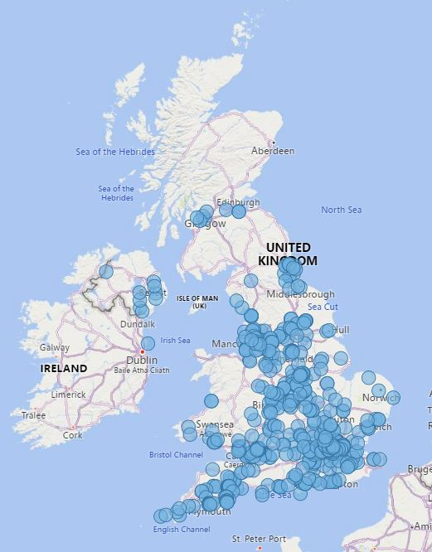

Gender Pay Gap Reporting
The gender pay gap shows the difference in the average pay between all men and women in a workforce. This is different to equal pay, which deals with the pay difference between men and women who carry out the same jobs, similar jobs of work value. It is unlawful to pay people unequally because they are a man or a woman.
Our gender pay gap for the period ending 31 March 2022 was 5.6%, a decrease of 0.9% from 6.5% in 2021. The table details our gender pay gaps over the last four years.
Gender Pay and Bonus Gap | 31 March 2019 | 31 March 2020 | 31 March 2021 | 31 March 2022
Mean Gender Pay Gap | 8.1% | 7.3% | 6.5% | 5.6%
Median Gender Pay Gap | 4.4% | 5.7% | 4.0% | 4.1%
Mean Bonus Pay Gap | 6.0% | 6.9% | 4.8% | 2.5%
Median Bonus Pay Gap | 1.1% | 1.3% | 1.1% | -0.5%
[Note: Approach changed in 2020 to align to Civil Service method using ACSES Data]

Comparison with the Civil Service
The table below compares our gender pay gap with the Civil Service (as a whole) gender pay gap.
Gender Pay | Met Office  31 March 2022 | Civil Service  31 March 2022
Mean Gender Pay Gap | 4.1% | 8.5%
Median Gender Pay Gap | 5.6% | 11.3%

ONS report that among full-time employees the gender pay gap for the UK in April 2022 was 8.3%.

Our Gender Pay Report 2022 provides more detailed analysis of our pay gap and the factors affecting the reduction in our pay gap.

Ethnicity Pay Gap reporting
We plan to start voluntarily reporting on our ethnicity pay gap. Like gender pay gap, ethnicity pay gap reporting should not be confused with equal pay, it shows the difference in the average hourly rate of pay between Black, Asian, and Minority Ethnic and White employees. This will be calculated using the same methodology as for gender pay gap reporting.
As part of being able to undertake this report, we need to amend some of our ethnicity reporting fields in our HR information system.

Workforce Diversity
As we work towards creating a more inclusive workplace, it’s important to understand the impact our decisions, activities and plans have on different groups of people. Analysing our data helps us understand the make-up of our organisation and how representative we are against the UK working age population and in the Southwest of the UK where our head office is located. It also gives us the opportunity to address issues of underrepresentation in certain areas and gives an idea of potential barriers facing our employees.
Data are collected through self-declaration in our HR Information System. Whilst we encourage employees to share their information, employees can use the ‘Prefer not to say’ or leave fields blank. This does mean we do not have the whole story about our organisation’s make-up but will keep working hard in the year ahead to encourage more employees to share their data.

Diversity data headlines
- Increased our staff diversity declaration rates to 94% in March 2023 from 91% in March 2022.
- Directorate staff diversity data declaration rates range from 93 to 98%.
- Part Time Full Time split: 83% of our staff are full-time and 17% part-time.
- Sex at Birth: 60% of our staff are male and 40% female at birth (HMRC data).
- Gender identity: 52% of our staff identify as male, 37.1% as female, 6.3% prefer not to say or declare another gender identity, and 4.6% are unknown.
- Religion or belief: 53.7% of our staff have no religion, 25.5% are Christian, 13.5% prefer not to say, 2.4% are other religion or belief, and 5% are unknown.
- Race/Ethnicity: 84.3% of our staff are white, 6% prefer not to say, 5.3% are minority ethnicities, and 4.4% are unknown.
- Sexual orientation: 76.5% of are staff identify as straight/heterosexual, 13.1% prefer not to say, 5.6% are LGBQA+ and 4.9% are unknown.
- Our 2022 People Survey indicated that 19.8% of staff had a health condition or illness lasting or expected to last 12 months or more, with a further 7.4% preferring not to say. The Office of National Statistics indicates that 22% of the working-age population are classed as disabled and that 35% of the working-age population report having a long-term health condition. (Source: The employment of disabled people 2022 – Office of National Statistics)
- The largest grouping of conditions relates to mental health conditions or illness. This is supported by our employee relations data.
- In any year we have around 12% of female staff on maternity leave.
- Inclusion and Fair Treatment theme score in the Civil Service People Survey remains at 83% which is 2% above the Civil Service wide average.
- Total number of employees is 2294 (as of 1 March 2023).
The appendix to this report details our workforce diversity data.

Further work to do on our data
We know there is much more we can do with our staff data including:
- Improving our diversity data, so encouraging employees to feel confident about sharing their data rather than prefer not to say.
- Being able to track the proportion of staff who have workplace adjustments, our new guidance and processes being developed should help with this.
- Publishing data on staff accessing learning and development opportunities.

Early Careers
We offer a range of early career programmes from work experience, apprenticeships, placements, graduate development, and doctoral training. In 2022, we launched our Early Years Careers Strategy, this aligns to our corporate and ED&I strategies and the Civil Service apprenticeship strategy. It also links with Educational Outreach and the Met Office Academic Partnerships and builds on our past success but ensures we remain flexible to our future skills requirements.
We have developed several principles to guide our strategy:
- The range of programmes are designed to offer long term development rather than fill immediate resource gaps.
- Programmes are supported by trained line managers, buddies and mentors with clear roles and responsibilities.
- Summer interns and industrial placements are a pipeline to graduate programmes.
- Apprenticeships are a pipeline for permanent roles.
- Educational outreach is an opportunity to increase attraction and engagement.

Our key activities in the last year include:
- Submitting bids to host a total of 9 interns across the Civil Service Autism Exchange Internship Programme and Summer Internship Programme 2023.
- Offering 2 engineering micro-internship summer 2023 opportunities for University of Plymouth students declared as neurodivergent and/or with a disability.
- Recruiting the first civil service Digital Accessibility apprentice.
- Recruiting new apprentices on Level 2-6 apprenticeships.
- Hosting sessions with our ED&I Team and Black Asian Minority Ethnic network lead as part of inductions for apprentices and industrial placements.
- Creation of application tips on early careers adverts to support those who may face barriers when applying for opportunities.

The following has been calculated based on headcount of employees whose primary roles fall within the staff category of ‘Apprentices’ or ‘Trainees and Placements’ as of 1st March 2023.
Sex | Proportion of group (%)
Male | 62.5%
Female | 37.5%

Ethnicity (Grouped) | Proportion of group (%)
White | 80.4%
Other Ethnic Minority Groups* | 10.7 -19.6%
Blank | <10.7%
Prefer not to say | 0%
*This includes Arab, Asian/Asian British; Mixed /Multiple Ethnic Groups.
Sexual Orientation (Grouped) | Proportion of group (%)
Heterosexual/Straight | 67.9%
LGBQA+ | 16.1%
Prefer not to say | <10.7%
Blank | <10.7%

Gender Identity (Grouped) | Proportion of group (%)
Male | 58.9%
Female | 32.1%
Identify In Another Way or Prefer Not to Say | <10.7%
Blank | <10.7%

Disability | Proportion of group (%)
Yes | 10.7%
No | 89.3%

Age Group | Proportion of group (%)
Under 25 | 80.4%
25-34 | 12.5%
35-44 | <10.7%
45-54 | <10.7%
55 – 64 | 0%
65 and over | 0%

Religion or belief | Proportion of group (%)
No Religion | 66.1%
Christian | 10.7%
Other Religion | <10.7%
Prefer not to say | <10.7%
Blank | <10.7%

Public customer data
Research undertaken in the last year identified there were certain groups and demographics that were less likely to have access to weather forecasts. These included:
- People aged 65+ with vulnerabilities.
- Low socioeconomic groups.
- Low employment or unemployed groups.
- Sole parents with children under 5.
- Homeless people/those living on the street or in sheltered accommodation.
We are taking actions as a result to ensure that such groups and demographics can be reached by the end of March 2024.

Looking ahead – ED&I Action Plan 2023-2024
Working with our Equality, Diversity, and Inclusion Committee, we have identified several actions which we want to work on over the next twelve months.

Objective 1 – Engaging with and understanding the diversity of our people and those we serve
- Work with the Southwest Civil Service ED&I Community of Practice to improve the outcomes for those who identify as having a long-term health condition/disability.
1.2 Explore the insights gained from improvements to ethnicity, sexual orientation, and carer fields in our HR data system.
1.3 Establish what ED&I insights arise from our Employee Value Proposition survey (Great Place to Work).
1.4 Examine the implications of the new BSL Act on our communications and engagement approaches.
1.5 Record and maintain demographic data on the young people that we engage with through our Education Outreach activities to evaluate and identify priority groups.

Objective 2 - Advancing equality of opportunity
2.1 Communicate the benefits of the new workplace adjustments passport so there is wide adoption and understanding.
2.2 Work with Business Disability Forum to submit a Disability Confident Leader award submission in 2024.
2.4 Providing information to our suppliers and partners to ensure they support our ED&I Strategy.
2.5 Developing a baseline of young people data and comparing with Met Office staff diversity data to inform priority groups for Education Outreach.

Objective 3 - Increasing representation of under-represented groups at all levels
3.1 Undertake a feasibility study of ethnicity pay gap reporting.
3.2 Partner with Institute of Physics and Royal Meteorological Society to address under-represented groups in the workforce.

Objective 4 - Zero tolerance to bullying, harassment and discrimination
4.1 Implement recommendations from the Civil Service Bullying, Harassment and Discrimination Strategy.
4.2 Develop assistance dogs’ guidance for all Met Office sites.
4.3 Publish our new our Safe Space to Speak Up guidance.
4.4 Develop a safety of women action plan in response to signing the Exeter Safety of Women at Night Charter and ensure this is covers other office locations.

Appendix: Workforce Diversity
We are showing our data over a three-year period which shows the impact the ED&I strategy, team and actions have had since March 2021. As of the 1 March 2023, 94% of staff had shared their diversity data.
The data uses headcount and includes:
- Staff
- Apprentices
- Trainees and Placements
- Sponsored Workers – Other
- Sponsored Workers – Tier 2

Sex
HMRC Gender Field | 1 March 2021  Proportion of staff | 1 March 2022  Proportion of staff | 1 March 2023  Proportion of staff | England & Wales comparator - ONS Census 2021
Male | 62.8% | 61.7% | 60.0% | 49%
Female | 37.2% | 38.3% | 40.0% | 51%

Gender identity –self reported

Gender Field | 1 March 2021  Proportion of staff | 1 March 2022  Proportion of staff | 1 March 2023  Proportion of staff | England & Wales comparator - ONS Census 2021
Male | 41.4% | 52.0% | 52.0% | unknown
Female | 28.2% | 34.9% | 37.1% | unknown
I identify in another way or prefer not to say | 3.3% | 7.1% | 6.3% | 6.3%#
Blank/unknown | 27.1% | 6.0% | 4.6% | unknown
# 6% undisclosed has been viewed as prefer not to say.

Ethnicity
Ethnicity (Grouped) | 1 March 2021 Proportion of staff | 1 March 2022  Proportion of staff | 1 March 2023  Proportion of staff | England & Wales comparator -ONS Census 2021
White ++ | 64.9% | 81.6% | 84.3% | 81.7%
Prefer Not to Say | 28.9% | 8.5% | 6.0% | Not applicable
Blank | 3.4% | 6% | 5.3% | Not applicable
Other Ethnic Minority Groups* ++ | 2.8% | 4.0% | 4.4% | 18.3%
*This includes Mixed /Multiple Ethnic Groups, Asian/Asian British; Black/African/ Caribbean/Black British/Other ethnic group.”
++ We are working to address ED&I fields in April to align to ONS best practice.

Sexual Orientation
Sexual Orientation (Grouped) | 1st March 2021 Proportion of staff | 1st March 2022  Proportion of staff | 1st March 2023  Proportion of staff | England & Wales comparator -ONS Census 2021
Heterosexual/ Straight | 59.3% | 74.3% | 76.5% | 89.4%
Prefer Not to Say | 29.0% | 12.2% | 13.1% | Not applicable
LGBQA+* | 4.1% | 4.9% | 5.6% | 3.2%
Blank | 7.6% | 8.6% | 4.9% | 7.5%
* This includes Bisexual/Pansexual, Gay/Lesbian, other Sexual Orientation.

Long Term Health Condition/Disability
Disability | 1st March 2021 Proportion of staff | 1st March 2022  Proportion of staff | 1st March 2023  Proportion of staff | England & Wales comparator -ONS Census 2021
Yes | 4.3% | 5.0% | 10.2% | 17.8%
No | 95.7% | 95.0% | 89.8% | 82.2%

Age
Age bands | 1 March 2021 Proportion of staff | 1 March 2022  Proportion of staff | 1 March 2023  Proportion of staff
25 and under | 5% | 6% | 6%
26 – 34 | 25% | 25% | 23%
35 – 44 | 27% | 27% | 29%
45 – 54 | 26% | 25% | 25%
55 – 64 | 15% | 16% | 16%
65 and over | 1% | 1% | 2%
[Note the Civil Service age comparison data does not align with our bandings but can be found here: Statistical bulletin - Civil Service Statistics: 2022 - GOV.UK (www.gov.uk)]
Religion or Belief
Religion or belief | 1 March 2021 Proportion of staff | 1 March 2022  Proportion of staff | 1 March 2023  Proportion of staff | England & Wales comparator -ONS Census 2021
No Religion | 38.9% | 50.2% | 53.7% | 37.2%
Christian | 20.5% | 25.5% | 25.5% | 46.2%
Prefer Not to Say | 9.2% | 13.5% | 13.5% | Not applicable
Blank | 29.4% | 8.6% | 5.0% | 6.0%
Other | 1.9% | 2.3% | 2.4% | 10.6%

Met Office
FitzRoy Road
Exeter
Devon
EX1 3PB
United Kingdom

Penny Endersby (Chief Executive), Tammy Lillie (Chief People Officer) and Jon Petch (Chair of ED&I Committee)
We count those completing 4 fields in people hub as a declaration.

