
National Climate Information Centre
Climate Memorandum No 29
Changes to the selection of stations used in the compilation of the United Kingdom Precipitation (HadUKP) series

Tim Legg
September 2011

Note: This document has not been published. Requests for permission to quote from it or to copy any part should be addressed to

Group Head, Climate Research
Met Office
FitzRoy Road
Exeter
Devon EX1 3PB

Contents

Introduction 3
Maps and lists of station locations 4
Comparison of old & new series 5
Conclusions 12
Appendices 12
References 13

Introduction

The HadUKP (United Kingdom Precipitation) series are updated each day in real-time, and include monthly and seasonal as well as daily totals. These series are maintained for several regions of the UK (see Figure 1), as well as for England & Wales as a whole and for Scotland as a whole. They are calculated from a set of observing stations which should give representative cover across the UK, for which roughly 100 stations are used. The original England & Wales (EWP) monthly series HadEWP extends back to 1766, though the regional series have later start dates. All the daily series begin in 1931. Because the range of stations available during that time has changed, the homogeneity of the series is preserved by normalising stations’ precipitation relative to the correct long-term local averages and by ensuring that the variance of the series has no artificial fluctuations.

Over recent years, due to station closures, the network of stations used to calculate the HadUKP rainfall series has become increasingly uneven. So now it has become necessary to re-visit the stations used. Fortunately, following the nationwide roll-out of the Met. Monitoring System (MMS) during 2009-10, many extra observing sites now exist. Hence a more uniform distribution of sites can be used, giving a more representative series. Using the improved network, we have re-calculated all daily and monthly totals, for all regions covered under HadUKP, from 1 January 2006 to 30 April 2011. By ensuring that calculations of areal statistics take account of differences between the normals of different stations, any artificial biases or step-changes in the rainfall amounts (when stations close or new ones open) have been minimised. Examples of the daily and monthly regional rainfall values are presented, to illustrate the differences. Generally the differences between the series calculated with old and new lists of stations are within the ‘noise’ level, with no systematic differences, except for Northern Ireland where the revised series is on average approximately 7% wetter.

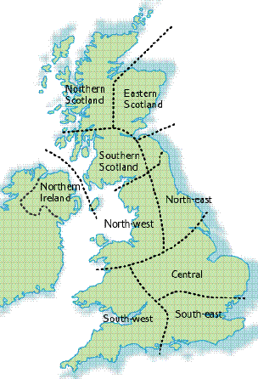

Figure 1: The areas of the UK covered by the regional rainfall series within UKP. Precipitation series for these regions are, moving north to south, denoted HadNSP, HadESP, HadSSP, HadNIP. HadNEEP, HadNWEP, HadCEP, HadSWEP and HadSEEP.

Maps and lists of station locations

Jones and Conway (1997) used seven evenly-distributed stations in each of the nine spatially-coherent precipitation regions which were defined previously by Wigley et al. (1984) for England & Wales and extended nationwide by Gregory et al. (1991). The stations used in these earlier studies were, as far as practicable, long-term ones which had remained open for several decades at least. However, Alexander and Jones (2001) presented a method for updating the series in near-real time which does not rely on the same set of stations remaining open but which still maintains true homogeneity. This means that, following various station closures over the past 15 years or so, other stations can be used, including some newly-opened sites. The requirement for having exactly 7 sites per region has also been removed; it was demonstrated (in Section 2 of Alexander and Jones, 2001) that a sufficiently representative series can be made from as few as 3 stations, but many more, up to 15 in some cases, could be used.

Hence the network has been allowed to vary in recent years, as some stations have indeed closed and some new sites have become available, and the earlier work does show that we can maintain homogeneous series despite changes to the network. However, during 2010 we realised that there were some large gaps appearing in the network, and so it was time to select some additional sites to ensure that we had a more even and representative geographical spread of observations.

Figure 2 shows the networks of stations used in HadUKP. Three different lists are included: (a) the original list of 107 stations whose data were sought by the daily update program as of 2010; (b) of these, the 77 stations which were actually still available in 2010; (c) the revised list of 119 stations, filling in the gaps and giving a more even spread of sites across the UK. Appendix I shows how many stations there are within each of the UK areas for each of these three sets of stations, and lists the sites in the revised set.

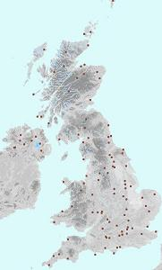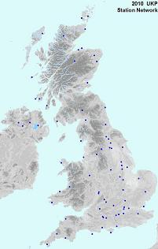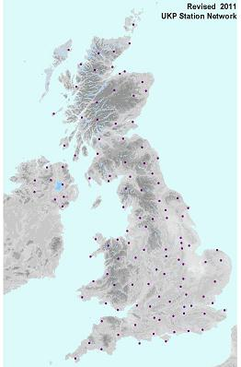
(a) (b) (c)
Figure 2: Networks of stations: (a) the stations whose rainfall data were looked for as of late-2010; (b) the stations whose data were actually found to be reliably available each day in late-2010; (c) the stations now used in HadUKP calculations, back-dated to the beginning of 2006.

Appendix I shows that the number of stations for which daily data were actually found had dropped to as few as 4 for each of Southern Scotland and Northern Ireland; the revisions have doubled these counts. Appendix I also gives the number of stations common to the revised network and the pre-2010 network, showing that the network has been changed least in Eastern Scotland and southern areas of England. (Appendix II lists the year of closure of those stations which have been lost from the network.) Thus now the number of stations in each region varies between 8 and 20; Eastern Scotland is the most sparsely represented region, whereas South-west England & Wales (which extends as far east as Wiltshire) contains the most stations. Note also (Figure 1) that Central England includes Lincolnshire, Norfolk and Suffolk as well as the Midlands, and that the area covered by North-east England also includes the south-east corner of Scotland.

The largest gaps in the network as it was in the latter part of 2010 (Figure 2(b)) were over most of central & western Scotland, parts of Northern Ireland, and inland parts of Wales, indicating a tendency for stations to be located preferentially in the more low-lying areas of the UK. We have been able to add several stations to fill in these gaps, to provide a more even spread across the UK (Figure 2(c)). This has been made possible since the implementation of MMS, giving some new sites (including in remote or mountainous areas) and also re-instating some other sites which had closed or become unreliable. MMS is described much more fully by Green (2010).

We were careful not to introduce any artificial biases in any of the rainfall series. For each region, to ensure consistency between dates when different selections of stations are available, the daily rainfall total for each station is multiplied by the ratio of the long-term averages of the region and of the individual station, then an average value is calculated from all available stations in that region. Reassuringly, we find that the average monthly HadEWP value for January 2006 – February 2011 altered by less than 1% when the series was re-calculated. The change is less than 3% in most individual districts, the exception being Northern Ireland which has become 7% wetter on average.

The list of stations whose data are searched for each day by the software we use is fixed at present. All the stations listed in Appendix I are used whenever available. However, we plan to check them at least every year to ensure that if any are found to have closed we add further ones to the list if necessary to ensure that the coverage remains even.

Comparison of old & new series

Graphical comparisons are shown here (Figures 3-8), for daily and monthly rainfall amounts (monthly graphs also include values from the nearest equivalent NCIC areal series for comparison), for several of the regions covered within the HadUKP series. These tend to show some variation amongst the daily values, but there are no systematic differences (except in Northern Ireland – see below), and variations amongst the monthly totals tend to be very small.

For EWP the magnitude of the difference between the daily values is rarely more than 2 mm (11 times out of the 1885 days in the comparison period), though for some individual regions the differences are occasionally as large as around 5 mm (for North-west England & Wales there are 163 days when the difference is 2 mm or more). Differences are occasionally larger in the cases of Eastern Scotland and Northern Ireland. Monthly totals for EWP never differ by more than 10 mm, and differ by more than 5 mm only 4 times out of the 62 months. Regionally, the majority of monthly differences are less than 5 mm, with the exception of Northern Ireland and to a lesser extent North-west England & Wales. A 5 mm discrepancy would make up to 10 places difference out of 81 or 139 years in mid-range regional historical rankings; a 3 mm discrepancy would make up to about 10 places difference out of 246 years in mid-range EWP rankings.

Correlations between old and revised rainfall figures are very high, above 0.98 for monthly values in most regions. Correlations for daily values are naturally a little lower, but still exceed 0.98 in some of the regions (Table 1). (Note that the daily correlations have been calculated by including all ‘zero-zero’ observation pairs, though in fact zero daily rainfalls over areas are surprisingly rare – there are lots of values which are very small but non-zero, however.)

The only real concern that has been identified by these graphs is for Northern Ireland. There were only four reliable stations covering this region prior to our revisions, with five other stations which had

(a) 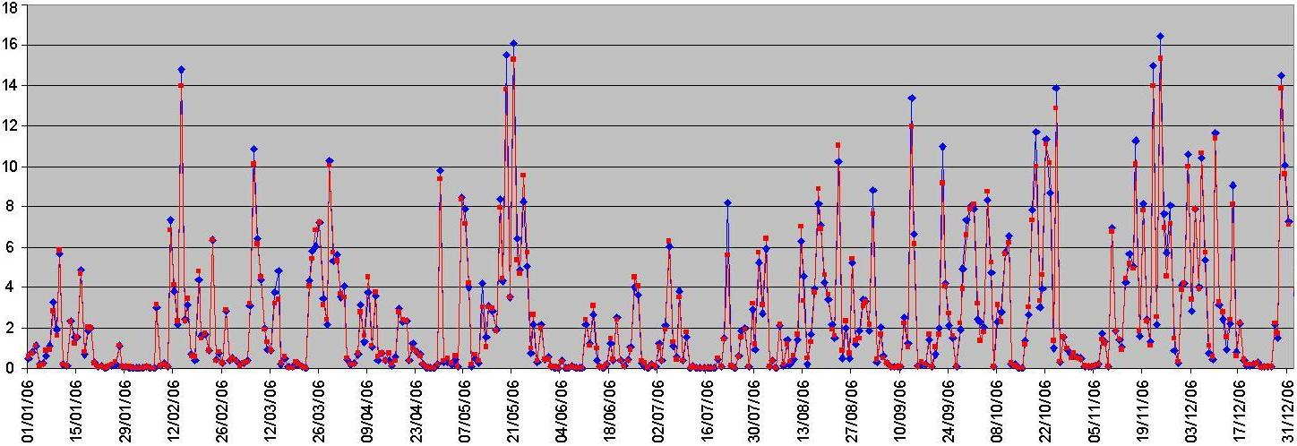
(b) 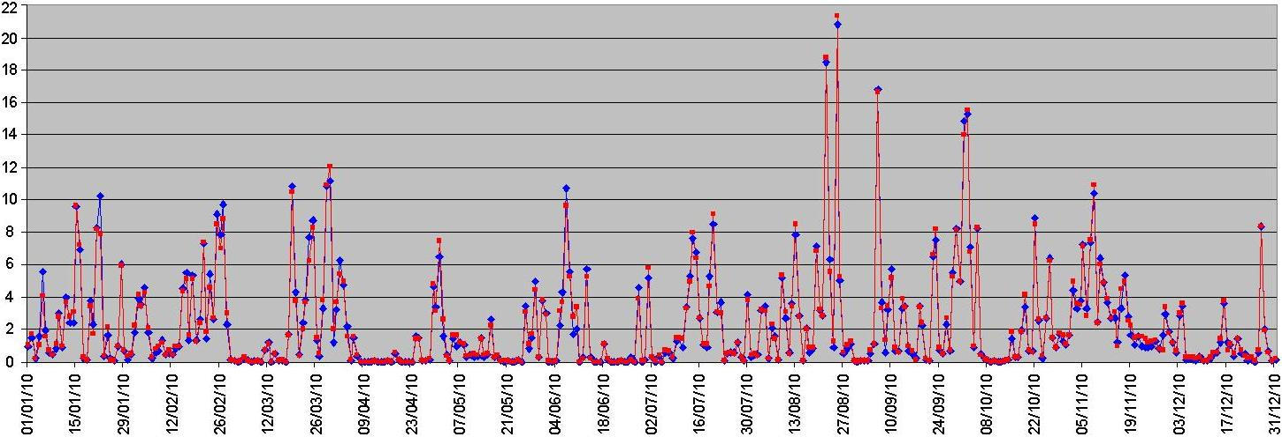
Figure 3: Time-series of daily HadEWP values; (blue) old series, (red) revised series. For (a) 2006, (b) 2010. Horizontal axis: dates. Vertical axis: rainfall, mm.

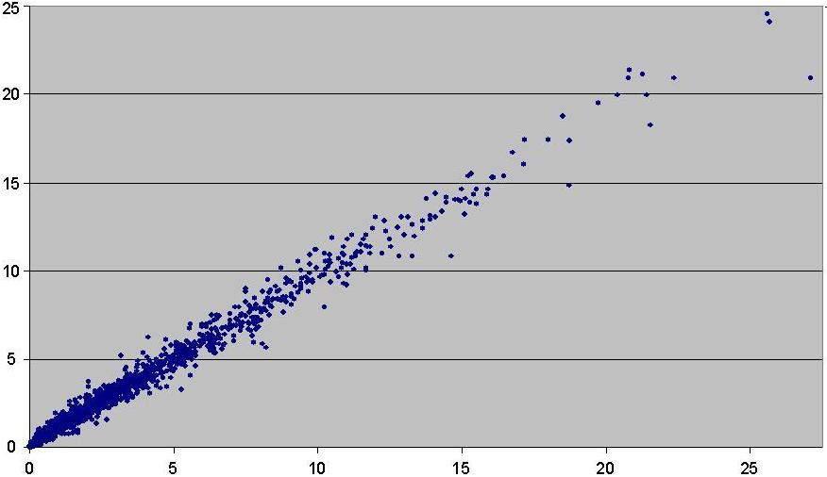
Figure 4: Scatterplot of daily HadEWP values, using all data for January 2006 to February 2011 inclusive. Original series plotted on horizontal axis, revised series on vertical axis. Amounts in mm.

(a) 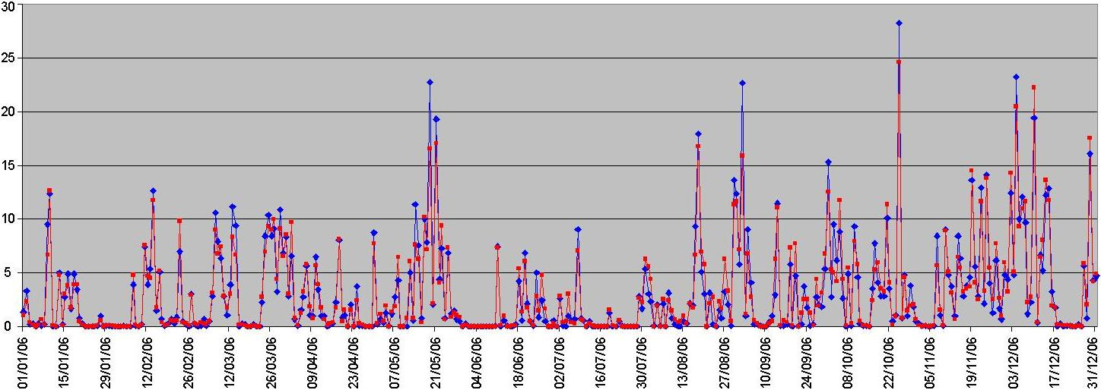
(b) 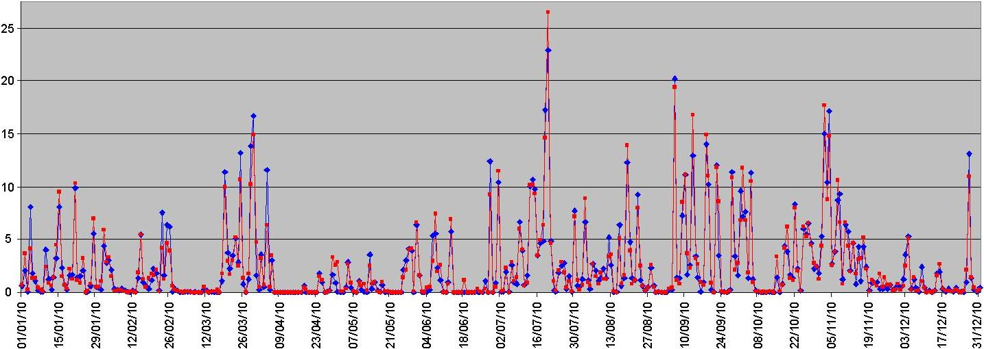
Figure 5: Time-series of daily HadNWEP values; (blue) old series, (red) revised series. For (a) 2006, (b) 2010. Horizontal axis: dates. Vertical axis: rainfall, mm.

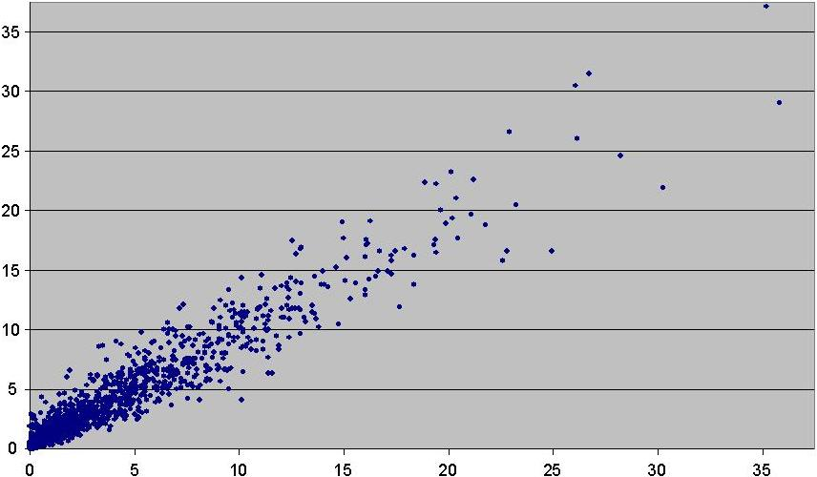
Figure 6: Scatterplot of daily HadNWEP values, using all data for January 2006 to February 2011 inclusive. Original series plotted on horizontal axis, revised series on vertical axis. Amounts in mm.

(a) 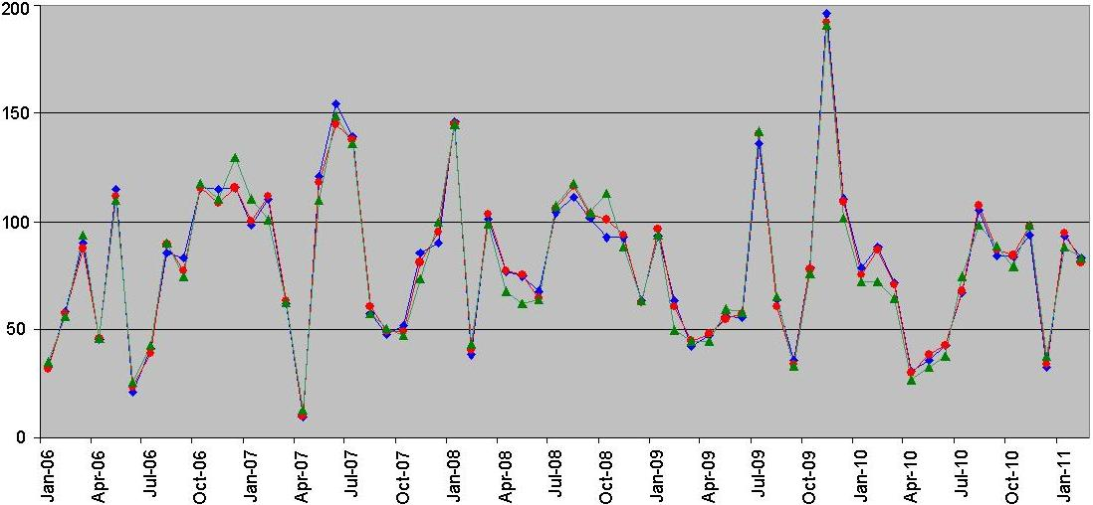

(b) 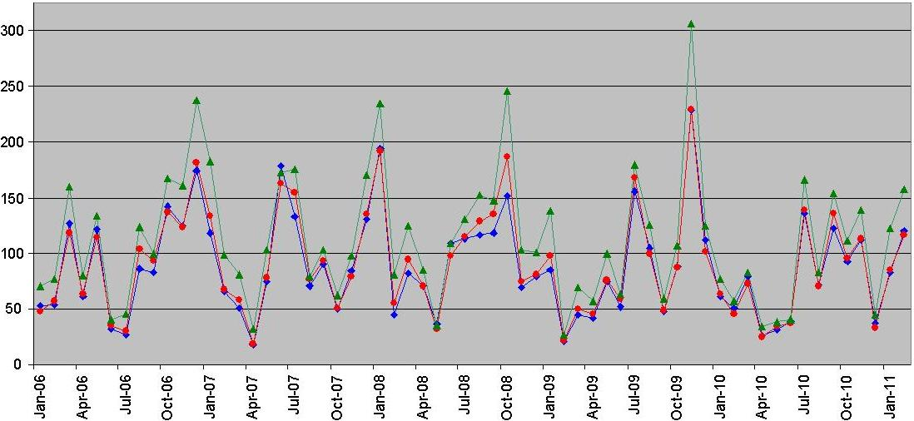

(c) 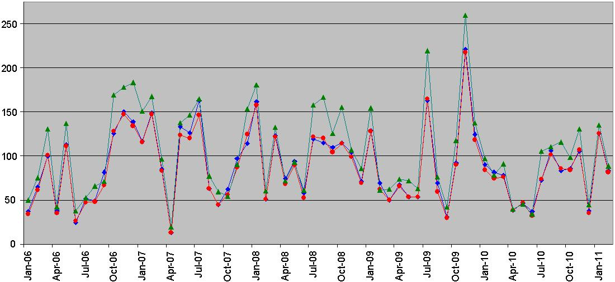

(d) 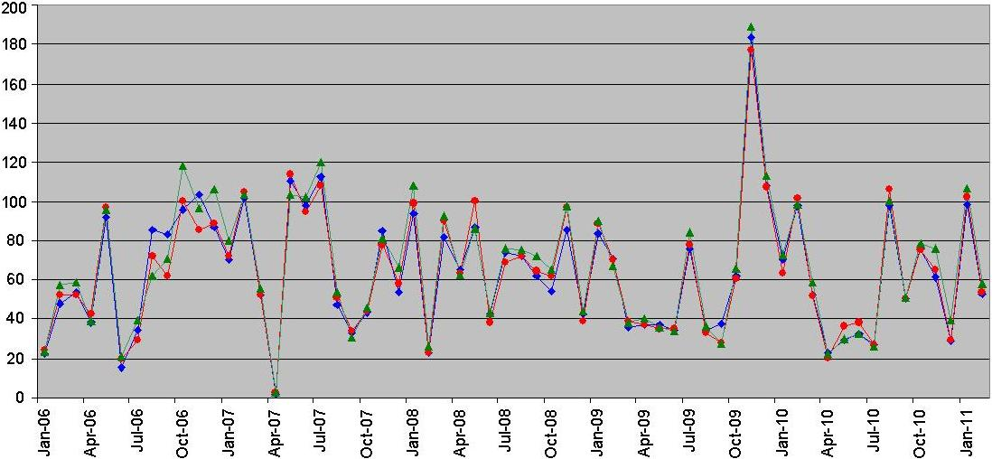

(e) 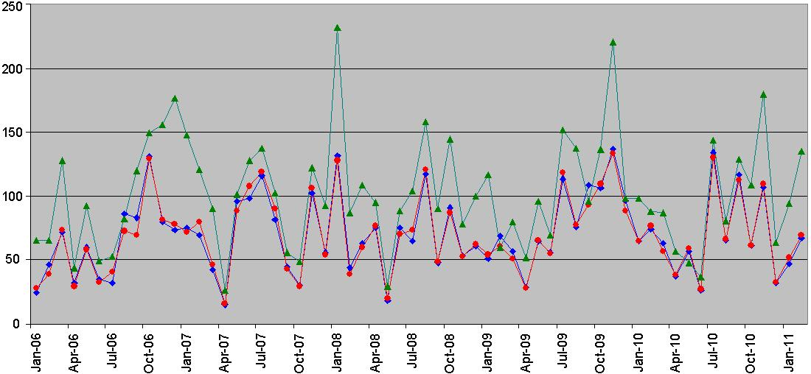

(f) 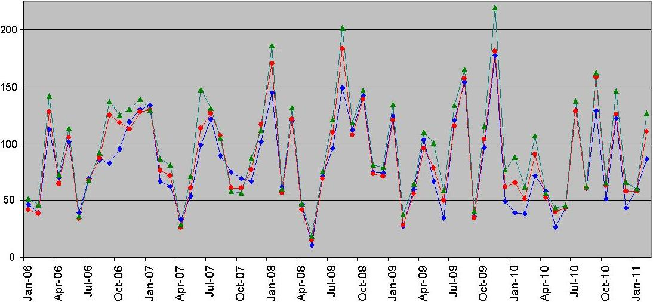
Figure 7. Time-series of monthly rainfall totals, January 2006 to February 2011. (Blue) old UKP series, (red) revised UKP series, and (green) NCIC areal values for comparison. Horizontal axis: dates. Vertical axis: rainfall, mm. For (a) England & Wales (EWP), (b) North-west England & Wales (NWEP), (c) South-west England & Wales (SWEP), (d) South-east England (SEEP), (e) Eastern Scotland (ESP), (f) Northern Ireland (NIP).

formerly been included having apparently closed or become unreliable. The revised list includes five more, i.e. nine stations in total. To further our comparisons for Northern Ireland, we can also compare with the monthly data in the NCIC climate series. The NCIC figures are based on a full network of stations, i.e. using every station for which measurements are available: in the ‘final’ quality-controlled network, including non-real-time stations, there are approximately 100 stations across Northern Ireland.

For January 2006 to February 2011, the monthly rainfall totals for Northern Ireland are shown in Figure 7(f). The rainfall totals from the revised HadNIP series are higher than the old series in most months, and the average difference in proportional terms is 7%. In months when the differences between old and revised HadNIP totals are larger (the revised values being wetter), the NCIC values are usually wetter even than these revised HadNIP values, for example in January, February and March 2010, so it appears that the revisions we have made to the HadNIP values are giving a better estimate of the “full-station network” values. November 2009 to May 2010 in fact seem to give consistently large differences between original and revised HadNIP monthly totals (many individual days during this period give higher totals for the revised series). Months with similar old and revised HadNIP values find closer agreement with the value from the NCIC series, for example in June, July and August 2010, though November 2010 is an exception. The HadNIP values following revision are much better correlated with the NCIC series: interestingly, the correlation between the monthly totals of the revised HadNIP series and the NCIC series is higher than that between the old and revised HadNIP series (Table 1). This gives us confidence in the revised HadNIP series; the fact that the revised values are on average 7% wetter is outweighed by it evidently being more realistic.

Examples of scatterplots of monthly totals for old and revised UKP series are shown in Figure 8, illustrating the high correlations. Figure 8(c) almost appears to suggest that there are two sets of points contributing to the graph for Northern Ireland, one aligned roughly parallel to and above the other – possibly suggesting a bias dependent on which particular stations were available in each month – though further investigation did not reveal this.

Having used the monthly values from the NCIC climate series in our comparisons for Northern Ireland precipitation, it is worth briefly comparing the HadUKP and NCIC series for some other regions (as shown in Figure 7). In many cases the region boundaries are not the same for both, but in other instances the areas are more similar (it is mainly these more-similar areas which were chosen as the examples for Figure 7). These show generally good agreement, though with a few discrepancies in months such as January and November 2010. Although the values for England & Wales are in very close agreement, there are biases in some of the individual regions; this is not an error, merely an artefact of how the regional normals depend on the station network used. Also, part of the bias for Eastern Scotland is due to the fact that for the UKP series the south-eastern corner of Scotland is included in the North-east England region.

(a) 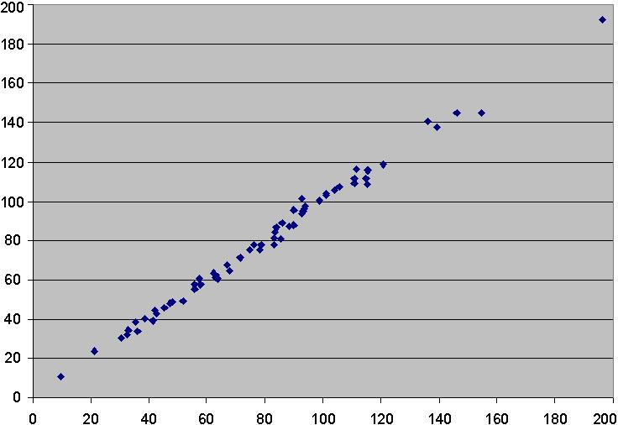

(b) 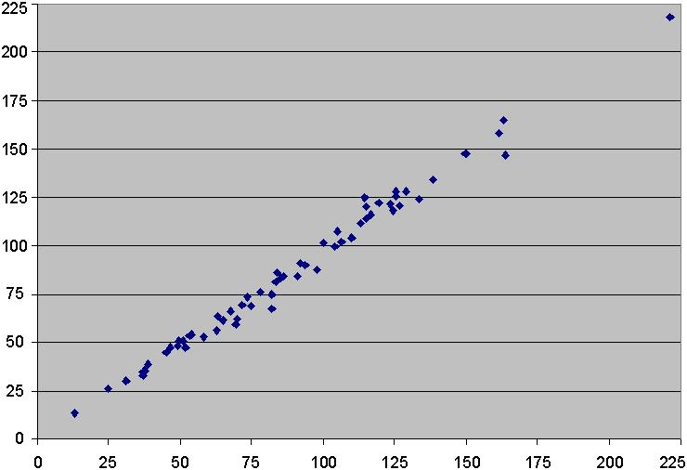

(c) 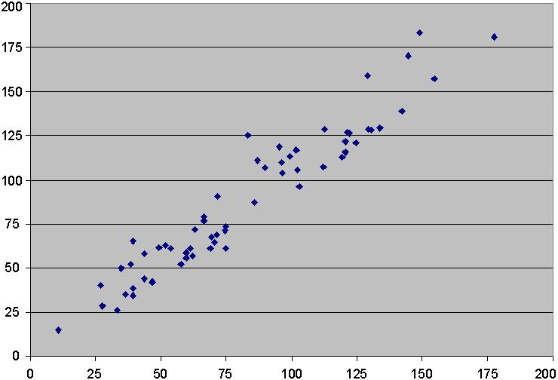
Figure 8: Scatterplots of monthly rainfall totals, for old and revised HadUKP series, using data for January 2006 to February 2011 inclusive. (a) England & Wales, (b) South-west England & Wales, (c) Northern Ireland. Original series plotted on horizontal axis, revised series on vertical axis. Amounts in mm.

Correlations between old and revised UKP series, and with the equivalent NCIC series, are shown in Table I for those cases where the NCIC regions are similar to or the same as the UKP regions. Rainfall totals have been compared, as before, for January 2006 to February 2011 inclusive. In all cases the revised UKP series are correlated more closely with the NCIC series, suggesting that the inclusion of extra stations to give a more even coverage is beneficial to the UKP series – most especially in N. Ireland and N. Scotland, where, noting that the correlation between old & revised UKP is lower, the revisions to the UKP station network have made the biggest difference. The old and revised UKP series are highly correlated, but, as one would expect, the correlations of the daily amounts are a little lower. Correlations between UKP and NCIC series have been explored in greater detail by Perry (2005).

Table I. Correlations between old & revised UKP series and equivalent NCIC series for monthly rainfall totals, and between old & revised UKP series for daily totals. (Period: Jan 2006 to Feb 2011)
 | Monthly values |  |  | Daily values
 | Old UKP v  Revised UKP | Old UKP v  NCIC series | Revised UKP  v NCIC series | Old UKP v  Revised UKP
England & Wales | 0.996 | 0.982 | 0.987 | 0.993
S.E. England | 0.982 | 0.976 | 0.983 | 0.977
S.W. England | 0.994 | 0.965 | 0.981 | 0.981
N.W. England | 0.984 | 0.964 | 0.982 | 0.964
N. Ireland | 0.958 | 0.939 | 0.987 | 0.926
E. Scotland | 0.985 | 0.820 | 0.843 | 0.972
N. Scotland | 0.952 | 0.872 | 0.968 | 0.934

Conclusions

The distribution of stations used in the United Kingdom Precipitation series had become rather uneven following various station closures. The selection of stations has now been expanded to give a more even coverage, and the series re-calculated since the beginning of 2006. The revised figures are more representative, while the methods used ensure that no artificial inhomogeneities have been introduced.

Appendix I
Number of stations available in each region: (a) according to original station list; (b) those stations on the original list that were still found to be reliably reporting during 2010; (c) according to updated station list. For (c), the stations are listed by name.
 | (a) | (b) | (c) | List of (c) | Overlap
S.E. England | 17 | 13 | 16 | Benson, East Malling, Heathrow, Herstmonceux, London (St James’s Park), Manston, Middle Wallop, Odiham, Rothamsted, Shoeburyness (Landwick), Shoreham Airport, Thorney Island, Wight (St Catherine’s Point), Wisley, Woburn, Writtle | 11  (69%)
S.W. England | 19 | 16 | 20 | Aberporth, Brize Norton, Cardinham (Bodmin), Chivenor, Culdrose, Exeter (Airport), Filton, Hereford (Credenhill), Hurn, Isle of Portland, Larkhill, Lyneham, Milford Haven, Mumbles Head, Pershore College, Plymouth Mountbatten, Sennybridge, St Athan, Trawsgoed, Yeovilton | 13  (65%)
Central England | 15 | 12 | 17 | Bedford, Church Lawford, Coleshill, Coningsby, Cottesmore, Cranwell, Leconfield, Marham, Norwich (Airport), Nottingham (Watnall), Scampton, Shawbury, Sutton Bonington, Waddington, Wattisham, Weybourne, Wittering | 12  (71%)
N.W. England | 10 | 6 | 15 | Aberdaron, Bingley, Capel Curig, Carlisle, Crosby, Hawarden, Keele, Keswick, Lake Vyrnwy, Rhyl, Rochdale, Stonyhurst, Valley, Walney Island, Warcop Range | 6  (40%)
N.E. England | 12 | 7 | 10 | Albemarle, Boulmer, Bridlington, Charterhall, Church Fenton, Durham, Fylingdales, Leeming, Linton-on-Ouse, Redesdale Camp | 5  (50%)
S. Scotland | 6 | 4 | 9 | Dundrennan, Edinburgh (Gogarbank), Eskdalemuir, Glasgow (Bishopton), Islay (Port Ellen), Machrihanish, Prestwick (Gannet), Threave, West Freugh | 4  (44%)
N. Scotland | 11 | 8 | 15 | Aultbea, Baltasound, Cassley, Dunstaffnage, Kinbrace (Hatchery), Kirkwall, Lerwick, Loch Glascarnoch, Skye (Lusa), Stornoway, Tain Range, Tiree, Tulloch Bridge, Tyndrum, Wick | 7  (47%)
E. Scotland | 7 | 6 | 8 | Aboyne, Aviemore, Dyce, Fyvie Castle, Kinloss, Leuchars, Lossiemouth, Strathallan (Airfield) | 6  (75%)
N. Ireland | 9 | 4 | 9 | Aldergrove, Altnahinch Filters, Ballykelly, Castlederg, Glenanne, Katesbridge, Killowen, Lough Fea, St Angelo | 3  (33%)
The “overlap” column indicates how many (and what proportion) of the stations in the revised network were also being included in the calculations immediately before revision.

Appendix II
Closure dates of the stations formerly used:-
Loch Carron (NSP) 2003, Lochluichart (NSP) 2003, Loch Rannoch (Power House) (NSP) 2006, Glenlivet (ESP) 2008, Glentress (ESP) 2005, Dumfries (Drungans) (SSP) 2004, Carmoney (NIP) 2004, Knockarevan (NIP) 2004, Moyola (Water Works) (NIP) 2004, Emley Moor (NEEP) 2010, Newcastle WC (NEEP) 2005, Tynemouth (NEEP) 2001, Whitby Coastguard (NEEP) 2002, Aspatria (NWEP) 2003, Cynwyd (NWEP) 2003, Moel-y-Crio (NWEP) 2005, Ringway (NWEP) 2004, Coltishall (CEP) 2006, Honington (CEP) 2003, Great Malvern (SWEP) 2008, Preston Wynne (SWEP) 2008, St Mawgan (SWEP) 2008, Beaufort Park (Bracknell) (SEEP) 2003, Southsea (SEEP) 2005.

References

Alexander, L.V. and Jones, P.D. 2001. Updated Precipitation Series for the U.K. and Discussion of Recent Extremes. Atmospheric Science Letters, Volume 1.

Green, A. 2010. From Observations to Forecasts - Part 7. A new meteorological monitoring system for the United Kingdom’s Met Office. Weather, 65, 272-277.

Gregory, J.M., Jones, P.D. and Wigley, T.M.L. 1991. Precipitation in Britain: an analysis of area-average data updated to 1989. Int. J. Climatol., 11, 331-345.

Jones, P.D. and Conway, D. 1997. Precipitation in the British Isles: an analysis of area-average data updated to 1995. Int. J. Climatol., 17, 427-438.

Perry, M. 2005. A comparison of NCIC monthly areal precipitation and temperature series with the EWP and CET series. Climate Memorandum No. 19. Met Office, Exeter.

Wigley, T.M.L., Lough, J.M. and Jones, P.D. 1984. Spatial patterns of precipitation in England and Wales and a revised, homogeneous England and Wales precipitation series. Int. J. Climatol., 4, 1-25.

