INDICATORS OF CHANGE
April – June 2011

CONTENTS

Climate Summary April – June 2011 p.4

- Global and Hemispheric Average Temperatures - annual anomalies p.5

- Global Average Temperatures - with respect to the end of the 19th century p. 6

- Near Surface Temperatures - annual anomalies p. 7

- Monthly Nino 3 Region Average SST p.8

- HadCRUT3 Anomalies - with respect to 1961-90 p.9

- Tropical (20˚S-20˚N) lower stratospheric and lower tropospheric temperature anomalies from satellites and radiosondes p.10

- England and Wales Precipitation - annual totals p.11

- England and Wales Precipitation - seasonal high summer and winter p.12

- Strength of North Atlantic Winter Westerlies p.13

- Central England Temperature and England and Wales Precipitation p.14

- UK precipitation anomalies with respect to 1961-90 p.15

Climate Summary April - June 2011

The global average temperature for January to June 2011 was 0.31±0.10˚C above the 1961-1990 average. If this 6 month average were treated as an annual average, 2011 would rank as the 13th warmest year on record, making the year the coolest year since 2000 at a ranking one position cooler than 2008.

A transition from La Niña conditions to neutral El Niño Southern Oscillation (ENSO) conditions occurred in the tropical Pacific in the first quarter of 2011 (Figure 4). Global average sea-surface temperature anomalies have warmed throughout 2011 in keeping with this transition and this gradual increase is similar to that observed following the 2007/2008 La Niña. Cool global average temperatures often accompany La Niña conditions and global temperatures often remain depressed during the months following such a transition.

Temperatures over land have been notably warmer in the second quarter of 2011 in comparison to the first (Figure 5), particularly in the northern hemisphere in April and June (average northern hemisphere temperature over land compared to 1961-1900 average: April, 1.15±0.30˚C; May, 0.69±0.22˚C; June, 0.95±0.18˚C). This has resulted in warmer global average temperatures than may have been expected given the recent La Niña conditions (global average temperature compared to 1961-1900 average: April, 0.40±0.14˚C; May, 0.32±0.17˚C; June, 0.43±0.15˚C).

In the Central England Temperature (CET) record the April average temperature (11.8˚C, 3.9˚C above average) was particularly warm (Figure 10). This was the warmest April average in the entire 353 year long series, surpassing the record set in 2007 by 0.6˚C. April 2011 was also the warmest April on record across the UK as a whole, surpassing 2007 by 0.5˚C. Temperatures in the CET region remained above average in May (12.2˚C, 1.0˚C above average) and fell below average in June (13.8˚C, 0.4˚C below average).

There has been a stark northwest-southeast contrast in precipitation across the UK (Figure 11). Northern Ireland and Scotland have received above average rainfall, with western areas of Scotland receiving over 170% of normal rainfall. England and Wales Precipitation (EWP) has been below average over the quarter of April to June 2011 (Figure 10), with large areas receiving less than 70% of normal rainfall. This follows a first quarter of the year that was also dry on average. The low rainfall in the EWP series for these two quarters results from an exceptionally dry two month period of March (20th driest March on record) and April (9th driest April on record). Following this dry period EWP returned to near normal in May and the quarter ended with a wet June.

Figure 1. Global and Hemispheric Average Temperatures: annual anomalies 1850 – June 2011. The red bars are the HadCRUT3 annual average combined sea-surface temperature and land-surface air temperature anomalies with respect to the 1961-90 average for the Northern Hemisphere, the Southern Hemisphere and for the Globe. The 2011 bar, up to June 2011, is shown in green. The blue lines show the data smoothed with a 21 term binomial filter and represent roughly decadal variability. The error bars show the 95% confidence range.

Figure 2. Global Average Temperatures with respect to the end of the 19th century 1850 – June 2011. The red bars are the HadCRUT3 annual average anomalies with respect to the end of the 19th century average (1861-1890). The 2011 bar, up to June 2011, is shown in green. The blue line shows the data smoothed with a 21 term binomial filter and represents roughly decadal variability.
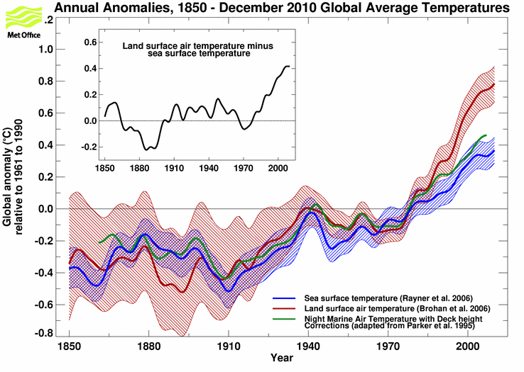
Figure 3. Near Surface Temperatures - annual anomalies 1850 – 2010. This graph shows how independently-measured sea-surface temperature, air temperature over land and air temperature over the oceans have followed similar trends through time. The data have been filtered using a 21-point binomial filter to highlight the longer term fluctuations. The sea surface temperature curve comes from the HadSST2 data set, the land surface temperatures come from the CRUTEM3 data set and the night marine air temperature curve comes from the MOHMAT43 data set. The shaded areas indicate the 2-standard error range on the smoothed land-surface and sea-surface data.
Figure 4. Monthly Nino 3 Region Average SST - 1982 – June 2011. This plot shows the monthly average sea surface temperature anomaly with respect to the 1961-90 reference period for the Niño 3 region that extends from 150-90˚W and from 5˚N-5˚S. Warm El Niño events in the eastern equatorial Pacific Ocean in 1982-83, 1987, and 1997-98 coincided with global warmth, but El Niño events are often followed by cooler La Niña events as in 1985, 1988, 1998-99, 2007-08 and 2010-11. The anomalies come from HadISST1, a globally complete series of sea ice and sea-surface temperatures.
Figure 5. HadCRUT3 anomalies (˚C) with respect to 1961-90 – April to June 2011. These maps show the near-surface temperature anomalies relative to the 1961-90 average. The anomalies come from the Hadley Centre and CRU Surface Temperature data set, HadCRUT3.
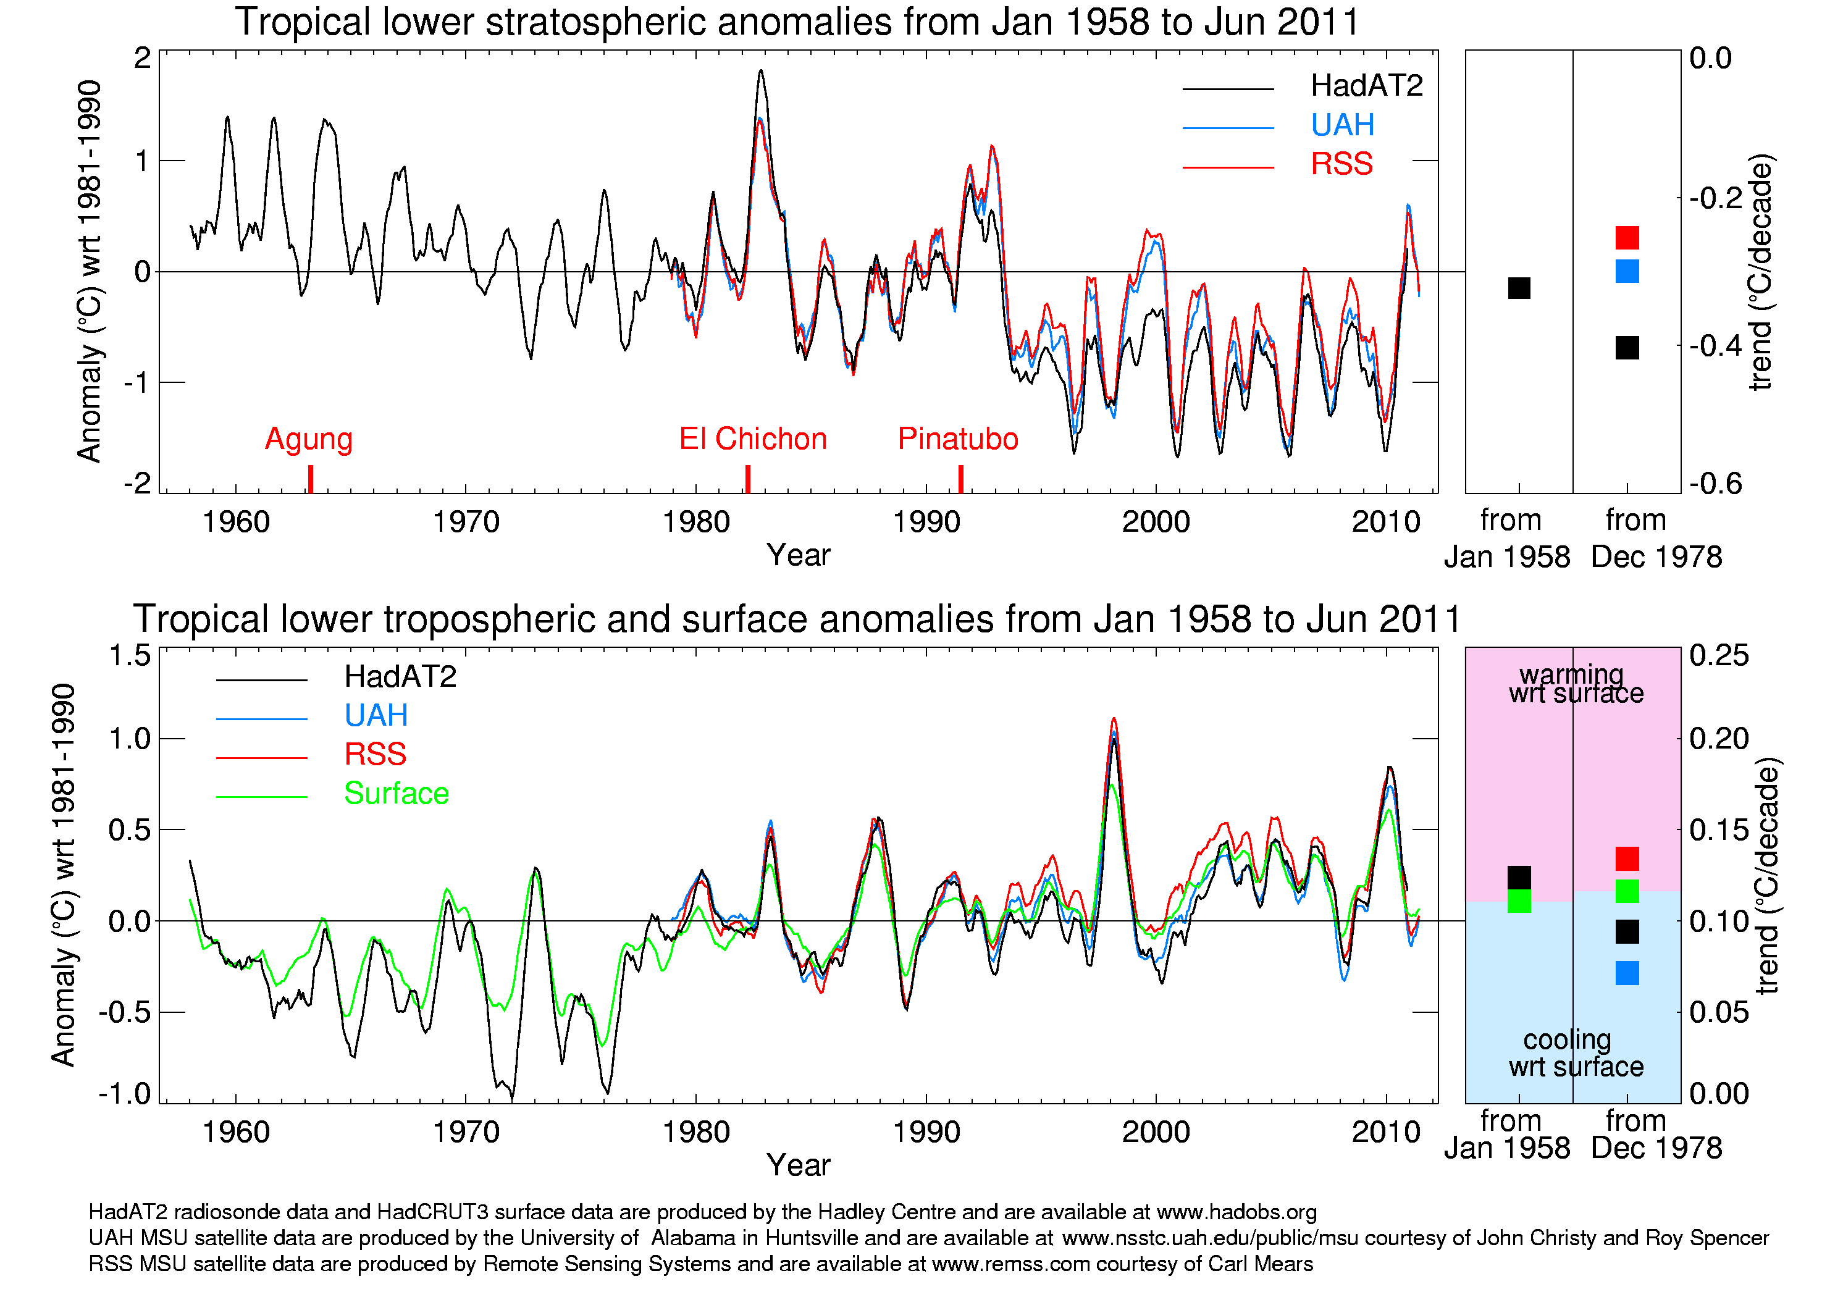
Figure 6: Tropical (20°S-20°N) lower stratospheric and lower tropospheric temperature anomalies from satellites and radiosondes January 1958 to June 2011. UAH (blue) and RSS (red) are two independently produced satellite estimates based upon the same Microwave Sounding Units (MSU) temperature retrievals. HadAT radiosonde data (black) have been vertically weighted to create an MSU-equivalent time series and the surface (green) temperature anomalies are based on HadCRUT3. HadAT2 data are shown for dates up to December 2010 and are next expected to be updated in 2012. The monthly series have all been smoothed using a simple 7-point moving filter. The squares on the right hand panels denote the trends for the radiosonde and satellite eras, calculated using the median of pair-wise slopes. The blue/pink areas on the tropospheric plot highlight tropospheric cooling/warming relative to the surface. Theoretical expectations are for greater warming in the troposphere than at the surface.
Figure 7. England and Wales Precipitation annual totals 1766-2010. The blue line represents the annual total precipitation for each year from 1766-2010. The smooth red curve shows the data after smoothing with a 21 term binomial filter and represents roughly decadal variability. The series is currently based on weighted averages of daily observations from a network of stations in five regions. It is the longest instrumental series of this kind in the world.
Figure 8. England and Wales Precipitation: seasonal high summer 1873-2010 and winter 1873-March 2011. This graph shows how summer and winter rainfall over England and Wales has changed since 1873. The red line shows the average summer (July-August) rainfall as a percentage change from the 1961-90 average after smoothing with a 21 term binomial filter and represents roughly the decadal variation in the series. The blue line shows the average winter (December-March) rainfall as a percentage change from the 1961-90 average after smoothing with a 21 term binomial filter and represents roughly the decadal variation in the series.
Figure 9. Strength of North Atlantic Winter Westerlies 1867 – 2011. The North Atlantic Oscillation (NAO) is a phenomenon associated with winter fluctuations in temperatures, rainfall and storminess over much of Europe. When the NAO is 'positive', westerly winds are stronger or more persistent, northern Europe tends to be warmer and wetter than average and southern Europe colder and drier. When the NAO is 'negative', westerly winds are weaker or less persistent, northern Europe is colder and drier and southern Europe warmer and wetter than average. There are a number of ways to calculate this index. Here it is calculated as the mean sea level pressure difference between SW Iceland and Ponta Delgada in the Azores. The blue bars show the yearly values for December to February and the red line shows the data after they have been smoothed on near decadal time scales by applying a 21 term binomial filter to the data three times. The green bar shows the average for the 2010/11 winter.
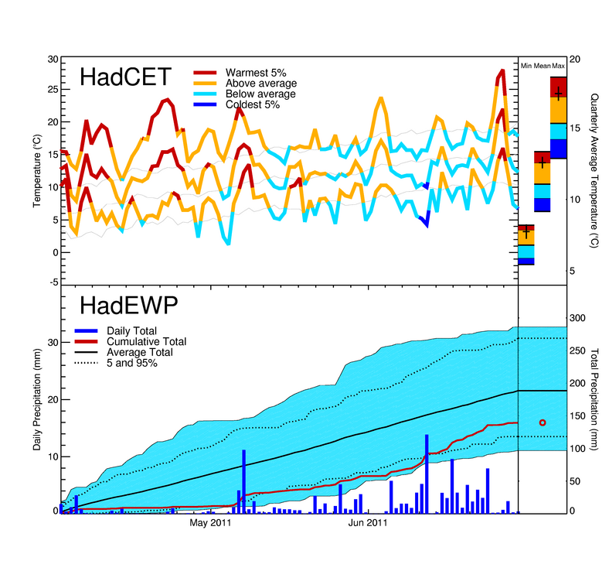

Figure 10. Central England Temperature (CET) and England and Wales Precipitation (EWP) daily series April to June 2011. Central England Temperature (CET) is representative of a roughly triangular area of the United Kingdom enclosed by Bristol, Manchester and London. The monthly series begins in 1659, and to date is the longest available instrumental record of temperature in the world. The three lines in the upper panel represent the daily maximum, mean and minimum Central England Temperatures. Where the daily values are above average, the line is coloured orange, where they fall below, the line is blue. Dark red and dark blue indicate that the daily temperature lay outside the range bounded by the 5th and 95th percentiles. The quarterly averages (April to June) for the minimum, mean and maximum are summarised in the upper-right-hand panel. The England and Wales Precipitation series, which extends back to 1766, provides a homogeneity-adjusted series of areally-averaged precipitation. The dark blue bars show the daily precipitation totals. The red line shows the cumulative precipitation total for the quarter. The blue shaded area indicates the lowest and highest cumulative totals and the dotted lines mark the 5th and 95th percentiles of accumulation based on statistics from the 1931 onwards daily series as a whole. The lower right-hand panel shows the three-month total for this quarter in red.
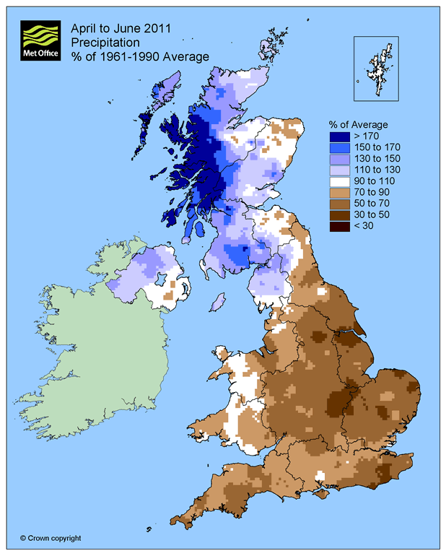

Figure 11. UK precipitation from the NCIC gridded dataset. Individual monthly 5 km gridded rainfalls were created using a network of around 300 stations. Allowances were made for topographic, coastal and urban effects where such relationships were found to exist. April to June totals were calculated from these gridded rainfalls and compared to the 1961-1990 1 km gridded rainfall averages for April to June.

